SQL
Data modeling:
Finding the primary key for ERD
- SQL QUERY: Checking the primary key of the columns
SELECT
tc.TABLE_NAME,
tc.CONSTRAINT_NAME AS Primary_Key_Name,
kcu.COLUMN_NAME,
kcu.ORDINAL_POSITION
FROM INFORMATION_SCHEMA.TABLE_CONSTRAINTS tc
JOIN INFORMATION_SCHEMA.KEY_COLUMN_USAGE kcu
ON tc.CONSTRAINT_NAME = kcu.CONSTRAINT_NAME
AND tc.TABLE_NAME = kcu.TABLE_NAME
WHERE tc.CONSTRAINT_TYPE = 'PRIMARY KEY'
ORDER BY tc.TABLE_NAME, kcu.ORDINAL_POSITION;
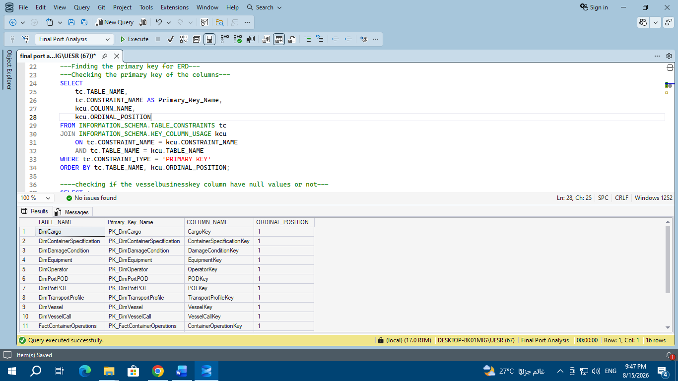
To know which table doesn’t have a primary key, as a result we will set a primary key for it.
As a result, I found that the [FactVesselPortCalls] and [CheckQCWorkingHours] tables don’t have a primary key.
So, now we will set a primary key for each of them.
- SQL QUERY: checking if the user_voy column have null values or not
SELECT *
FROM [FactVesselPortCalls]
WHERE User_Voy IS NULL
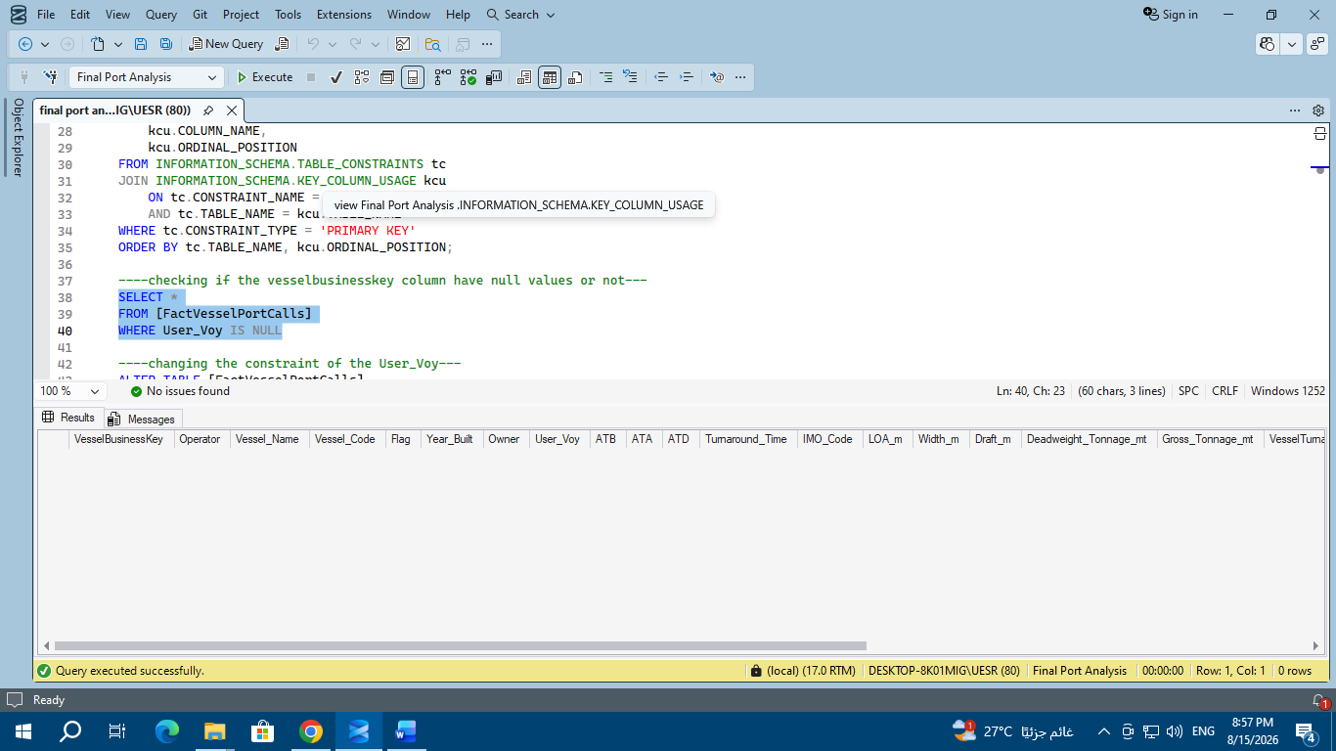
Finding that the user_voy doesn’t have null values.
- checking that the user_voy column have no duplicates
SELECT
user_voy,
COUNT(*) AS Duplicate_Count
FROM [FactVesselPortCalls]
GROUP BY User_Voy
HAVING COUNT(*) > 1

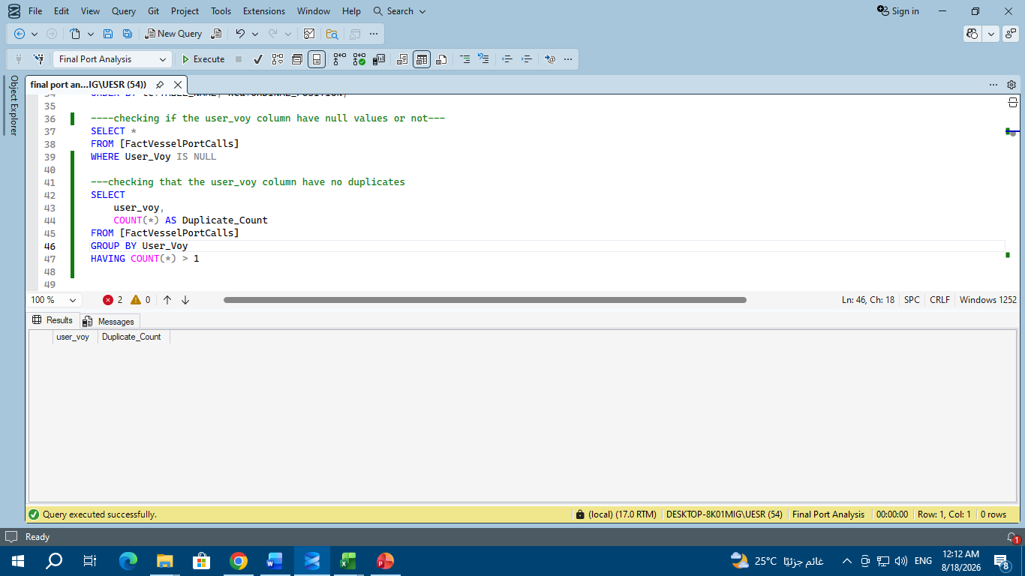

- SQL QUERY: Adding the primary key of the [FactVesselPortCalls]
ALTER TABLE [FactVesselPortCalls]
ADD CONSTRAINT PK_FactVesselPortCalls
PRIMARY KEY (User_Voy)

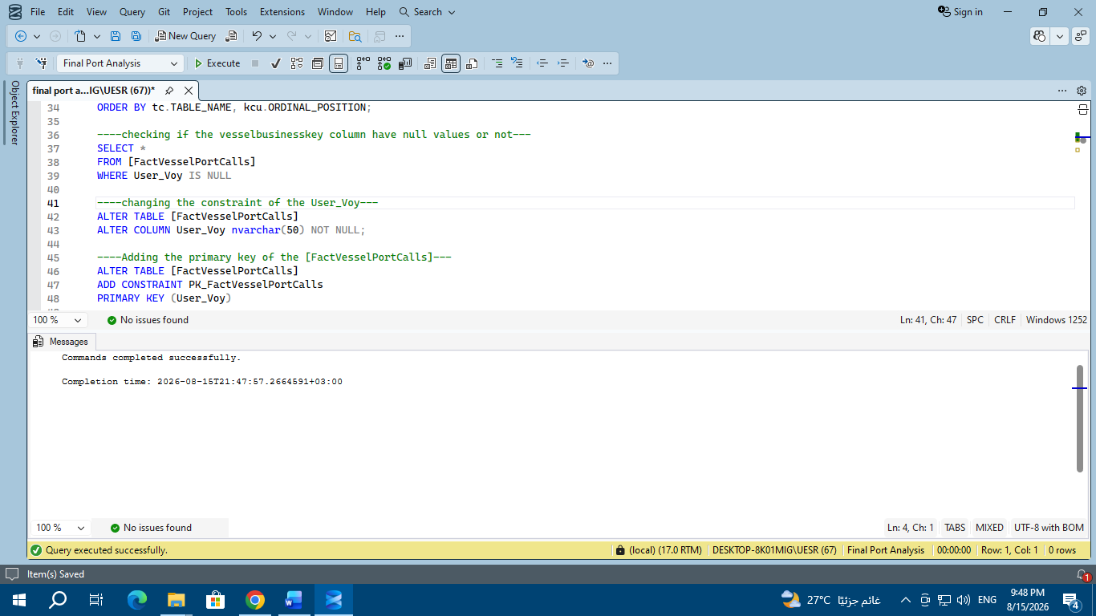

- SQL QUERY: checking that the type of the columns is correct
SELECT TABLE_NAME
FROM INFORMATION_SCHEMA.TABLES;
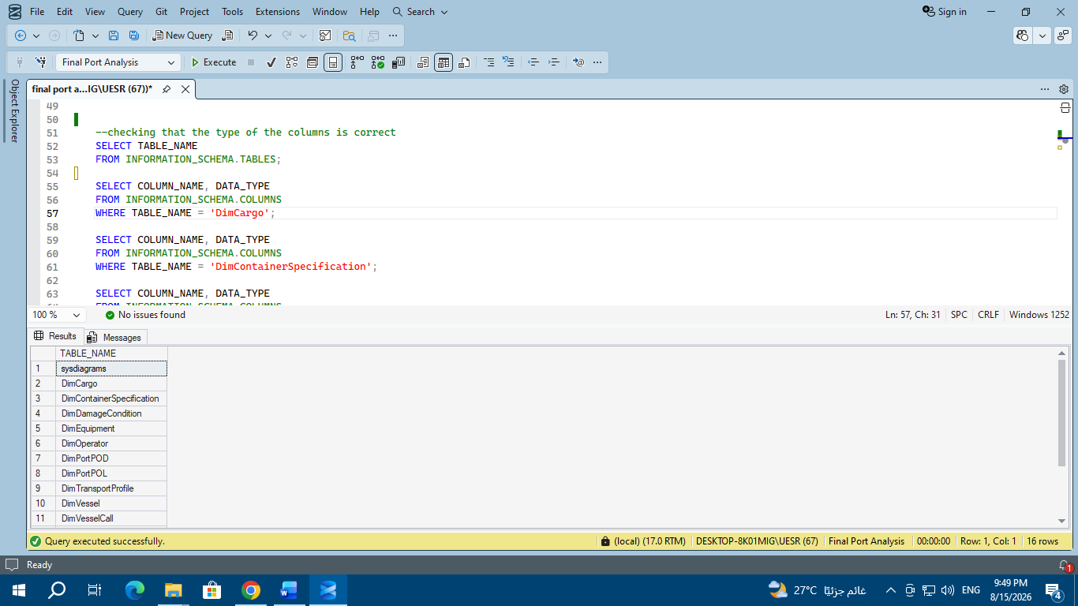

SELECT COLUMN_NAME, DATA_TYPE
FROM INFORMATION_SCHEMA.COLUMNS
WHERE TABLE_NAME = 'DimCargo';
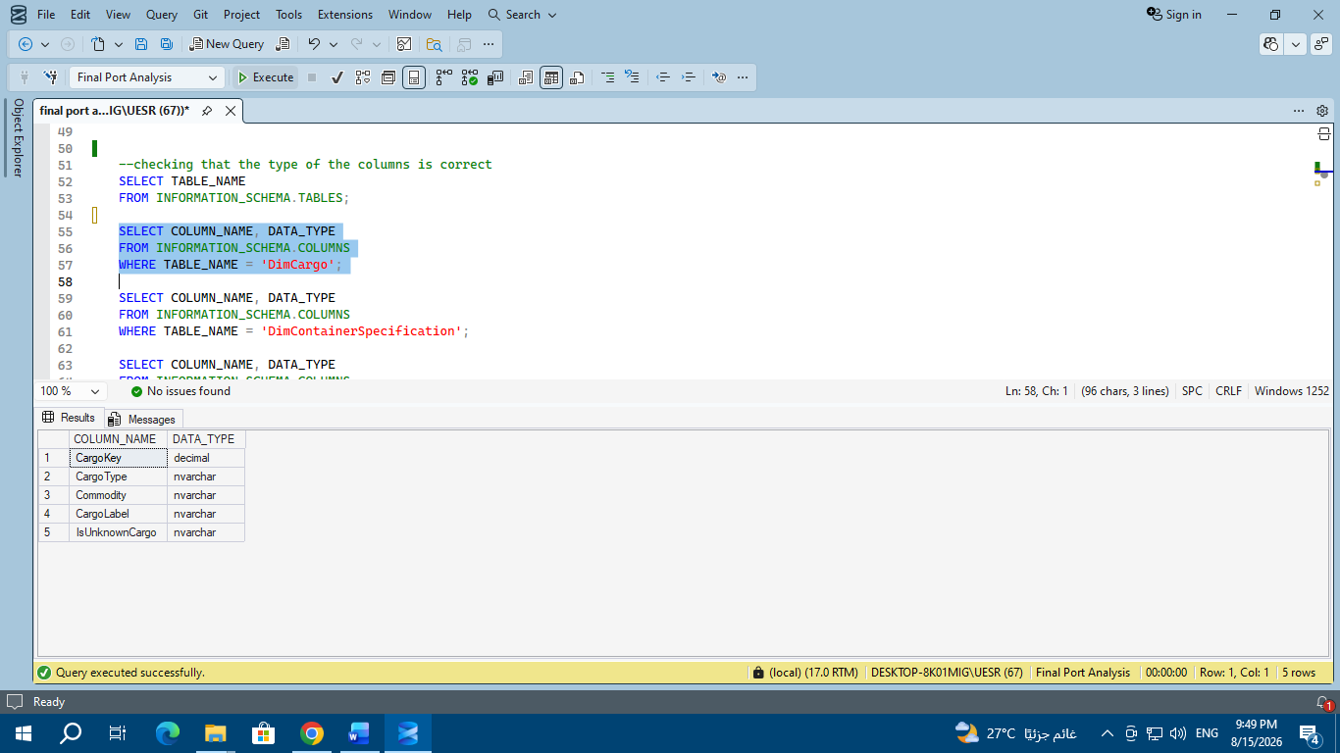

SELECT COLUMN_NAME, DATA_TYPE
FROM INFORMATION_SCHEMA.COLUMNS
WHERE TABLE_NAME = 'DimContainerSpecification';
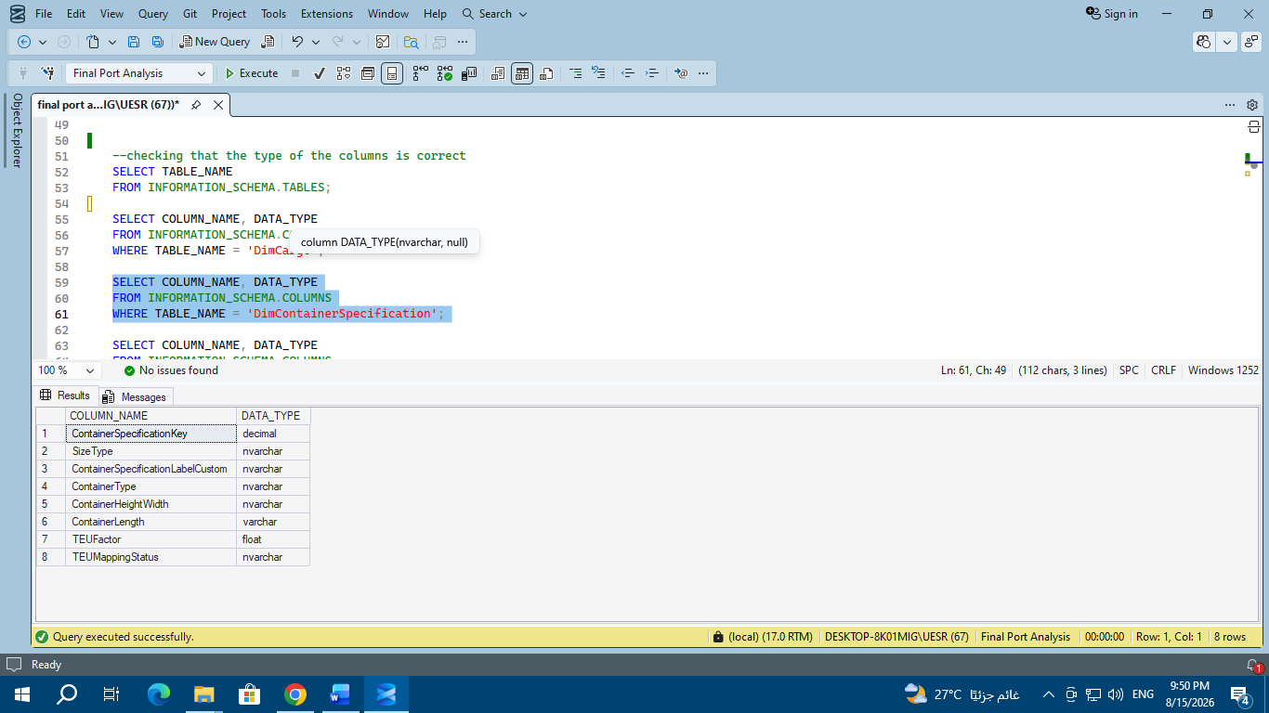

SELECT COLUMN_NAME, DATA_TYPE
FROM INFORMATION_SCHEMA.COLUMNS
WHERE TABLE_NAME = 'DimDamageCondition';

SELECT COLUMN_NAME, DATA_TYPE
FROM INFORMATION_SCHEMA.COLUMNS
WHERE TABLE_NAME = 'DimEquipment';

SELECT COLUMN_NAME, DATA_TYPE
FROM INFORMATION_SCHEMA.COLUMNS
WHERE TABLE_NAME = 'DimOperator';

SELECT COLUMN_NAME, DATA_TYPE
FROM INFORMATION_SCHEMA.COLUMNS
WHERE TABLE_NAME = 'DimPortPOD';

SELECT COLUMN_NAME, DATA_TYPE
FROM INFORMATION_SCHEMA.COLUMNS
WHERE TABLE_NAME = 'DimPortPOL';

SELECT COLUMN_NAME, DATA_TYPE
FROM INFORMATION_SCHEMA.COLUMNS
WHERE TABLE_NAME = 'DimTransportProfile';

SELECT COLUMN_NAME, DATA_TYPE
FROM INFORMATION_SCHEMA.COLUMNS
WHERE TABLE_NAME = 'DimVessel';

SELECT COLUMN_NAME, DATA_TYPE
FROM INFORMATION_SCHEMA.COLUMNS
WHERE TABLE_NAME = 'DimVesselCall';

SELECT COLUMN_NAME, DATA_TYPE
FROM INFORMATION_SCHEMA.COLUMNS
WHERE TABLE_NAME = 'FactContainerOperations';

SELECT COLUMN_NAME, DATA_TYPE
FROM INFORMATION_SCHEMA.COLUMNS
WHERE TABLE_NAME = 'FactQCPerformance';

SELECT COLUMN_NAME, DATA_TYPE
FROM INFORMATION_SCHEMA.COLUMNS
WHERE TABLE_NAME = 'FactVesselPortCalls';

SELECT COLUMN_NAME, DATA_TYPE
FROM INFORMATION_SCHEMA.COLUMNS
WHERE TABLE_NAME = 'POD_Master';

SELECT COLUMN_NAME, DATA_TYPE
FROM INFORMATION_SCHEMA.COLUMNS
WHERE TABLE_NAME = 'PortMaster';

These queries help to know the column name and its type for each table.

- Uniting the data typs of the columns
alter table [factcontaineroperations]
alter column vesselcallkey int

alter table [factcontaineroperations]
alter column operatorkey tinyint

alter table [factcontaineroperations]
alter column dimequipment_equipmentkey tinyint

alter table [factcontaineroperations]
alter column dimdamagecondition_damageconditionkey tinyint

alter table [factqcperformance]
alter column vesselcallkey int

alter table [factqcperformance]
alter column equipmentkey tinyint

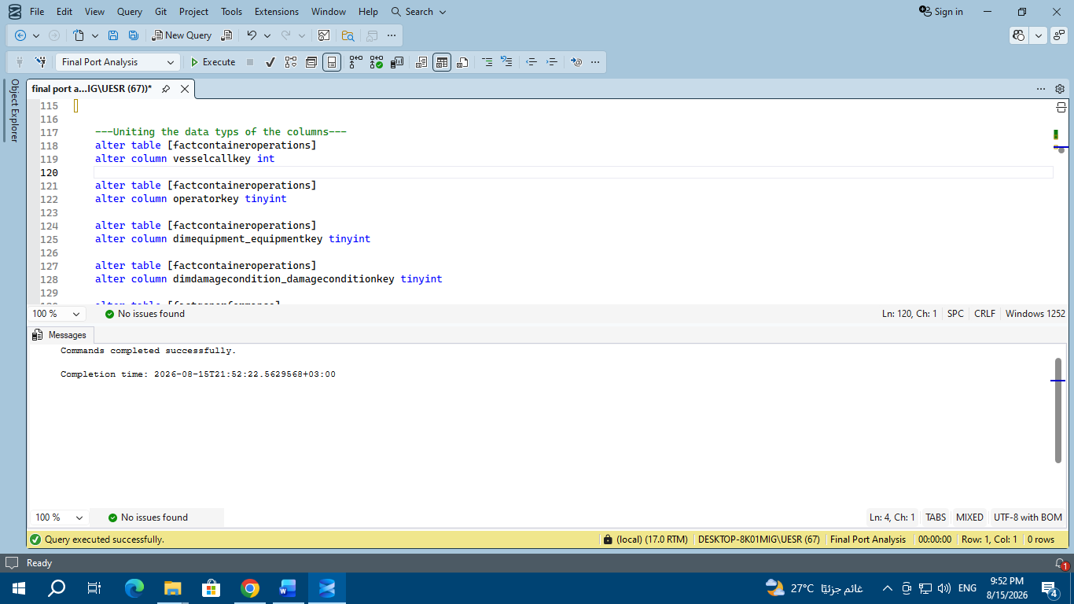

In order to join two tables together through the primary and foreign keys, the two columns in the two tables should have the same data type, so, during the process of joining the tables together, I found that some columns don’t have the same type of data. So, I used these queries to unite the data types of the columns of the tables that are used to join the tables together.

- SQL QUERY: Setting the foreignkeys

ALTER TABLE FactContainerOperations
ADD CONSTRAINT FK_FCO_VesselCall
FOREIGN KEY (VesselCallKey) REFERENCES DimVesselCall (VesselCallKey);

ALTER TABLE FactContainerOperations
ADD CONSTRAINT FK_FCO_Operator
FOREIGN KEY (OperatorKey) REFERENCES DimOperator (OperatorKey);

ALTER TABLE FactContainerOperations
ADD CONSTRAINT FK_FCO_ContainerSpecification
FOREIGN KEY (ContainerSpecificationKey) REFERENCES DimContainerSpecification (ContainerSpecificationKey);

ALTER TABLE FactContainerOperations
ADD CONSTRAINT FK_FCO_Cargo
FOREIGN KEY ([DimCargo_CargoKey]) REFERENCES DimCargo (CargoKey);

ALTER TABLE FactContainerOperations
ADD CONSTRAINT FK_FCO_POL
FOREIGN KEY ([DimPortPOL_POLKey]) REFERENCES DimPortPOL (POLKey);

ALTER TABLE FactContainerOperations
ADD CONSTRAINT FK_FCO_Equipment
FOREIGN KEY ([DimEquipment_EquipmentKey]) REFERENCES DimEquipment (EquipmentKey);

ALTER TABLE FactContainerOperations
ADD CONSTRAINT FK_FCO_POD
FOREIGN KEY (PODKey) REFERENCES DimPortPOD (PODKey);

ALTER TABLE FactContainerOperations
ADD CONSTRAINT FK_FCO_DamageCondition
FOREIGN KEY ([DimDamageCondition_DamageConditionKey]) REFERENCES DimDamageCondition (DamageConditionKey);

ALTER TABLE FactContainerOperations
ADD CONSTRAINT FK_FCO_TransportProfile
FOREIGN KEY ([DimTransportProfile_TransportProfileKey]) REFERENCES DimTransportProfile (TransportProfileKey);

ALTER TABLE FactQCPerformance
ADD CONSTRAINT FK_FQC_VesselCall
FOREIGN KEY (VesselCallKey) REFERENCES DimVesselCall (VesselCallKey);

ALTER TABLE FactQCPerformance
ADD CONSTRAINT FK_FQC_Equipment
FOREIGN KEY (EquipmentKey) REFERENCES DimEquipment (EquipmentKey);

ALTER TABLE POD_Master
ADD CONSTRAINT UQ_PODMaster_Code UNIQUE (PODCode);

ALTER TABLE DimPortPOD WITH NOCHECK
ADD CONSTRAINT FK_DimPortPOD_PODMaster
FOREIGN KEY (PODCode) REFERENCES POD_Master (PODCode);

ALTER TABLE PortMaster
ADD CONSTRAINT UQ_PortMaster_Code UNIQUE (PortCode);

ALTER TABLE DimPortPOL
ADD CONSTRAINT FK_DimPortPOL_PortMaster
FOREIGN KEY (POLCode) REFERENCES PortMaster (PortCode);

ALTER TABLE DimVessel
ADD CONSTRAINT UQ_DimVessel_BusinessKey UNIQUE (VesselBusinessKey);

ALTER TABLE DimVesselCall
ADD CONSTRAINT FK_DVC_Vessel
FOREIGN KEY (VesselBusinessKey) REFERENCES DimVessel (VesselBusinessKey);

ALTER TABLE FactVesselPortCalls
ADD CONSTRAINT FK_FVPC_Vessel
FOREIGN KEY (VesselBusinessKey) REFERENCES DimVessel (VesselBusinessKey);

ALTER TABLE DimOperator
ADD CONSTRAINT UQ_DimOperator_Code UNIQUE (OperatorCode);

ALTER TABLE FactVesselPortCalls WITH NOCHECK
ADD CONSTRAINT FK_FVPC_Operator
FOREIGN KEY (Operator) REFERENCES DimOperator (OperatorCode);

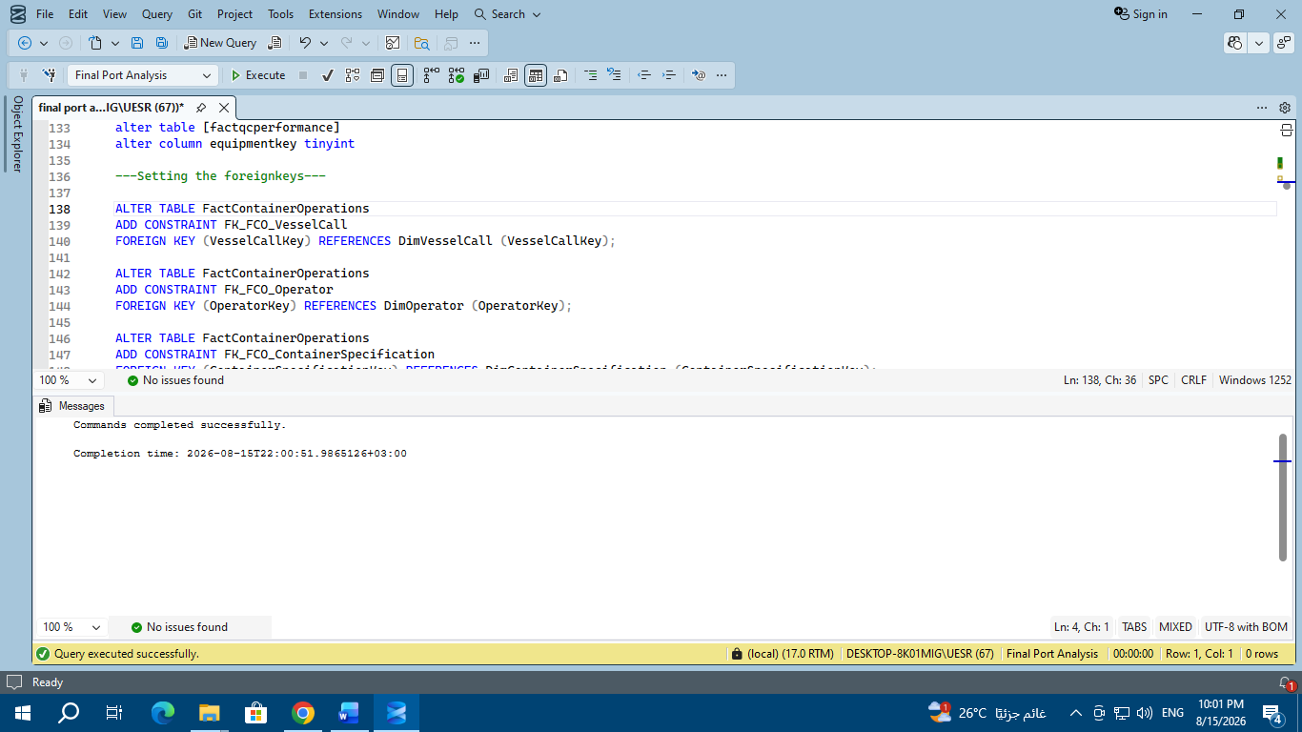

Now, after setting the primary key for each table, in order to join these tables together, I need to make foreign keys.

The final ERD
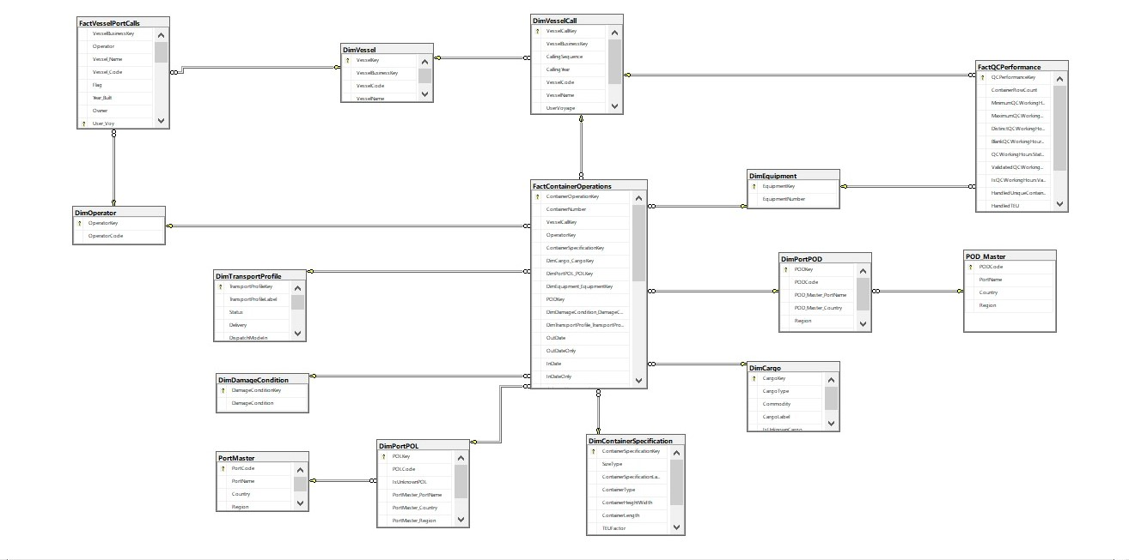

- SQL QUERY: Deleting two unuseful rows
DELETE FROM [FactContainerOperations]
WHERE containeroperationkey IN (48676, 48677);

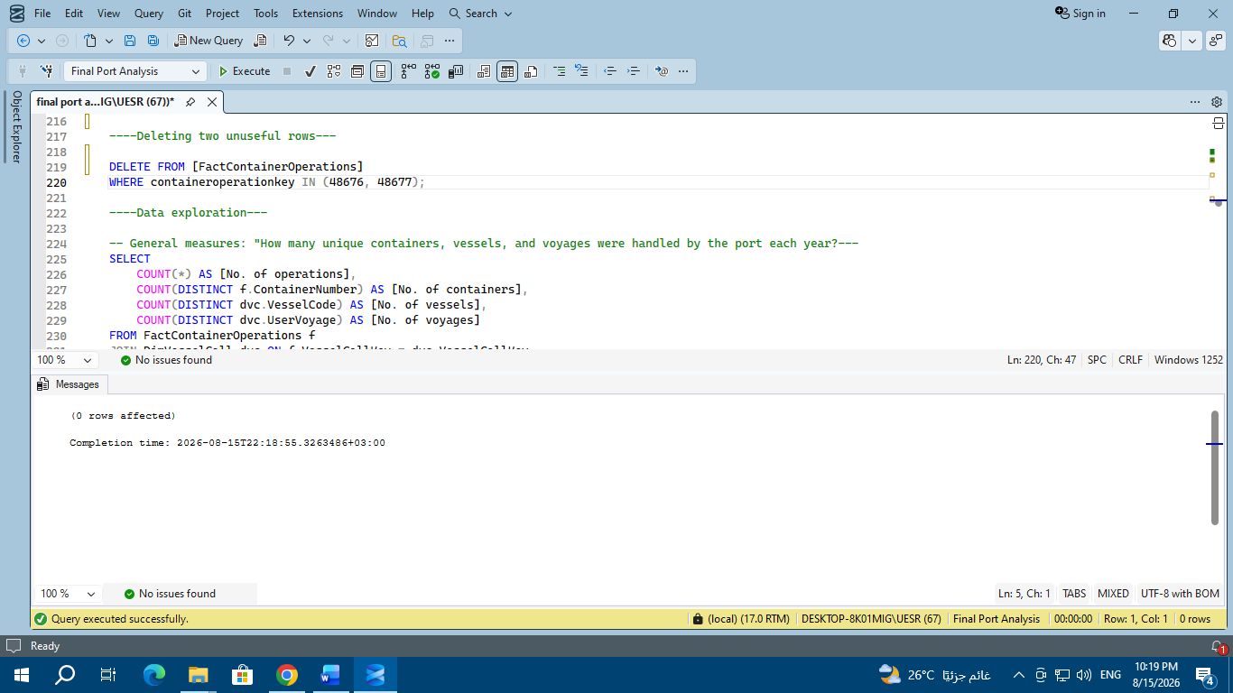

During my journey of exploring data, I found two rows that most of their records are null, so, these two rows are not useful for us. So, the best choice is to delete these two rows.

----Data exploration and data analysis---
- General measures: "How many unique containers, vessels, and voyages were handled by the port each year?
SELECT
COUNT(*) AS [No. of operations],
COUNT(DISTINCT f.ContainerNumber) AS [No. of containers],
COUNT(DISTINCT dvc.VesselCode) AS [No. of vessels],
COUNT(DISTINCT dvc.UserVoyage) AS [No. of voyages]
FROM FactContainerOperations f
JOIN DimVesselCall dvc ON f.VesselCallKey = dvc.VesselCallKey
WHERE dvc.CallingYear IN (2025, 2026);
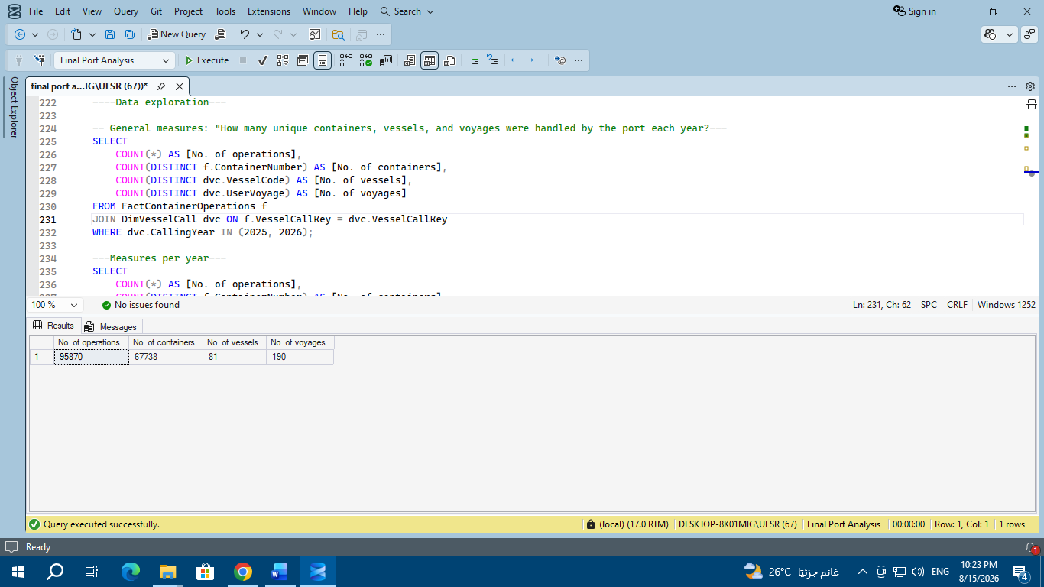

- Measures per year

SELECT
COUNT(*) AS [No. of operations],
COUNT(DISTINCT f.ContainerNumber) AS [No. of containers],
COUNT(DISTINCT dvc.VesselCode) AS [No. of vessels],
COUNT(DISTINCT dvc.UserVoyage) AS [No. of voyages],
dvc.CallingYear
FROM FactContainerOperations f
JOIN DimVesselCall dvc ON f.VesselCallKey = dvc.VesselCallKey
GROUP BY dvc.CallingYear;

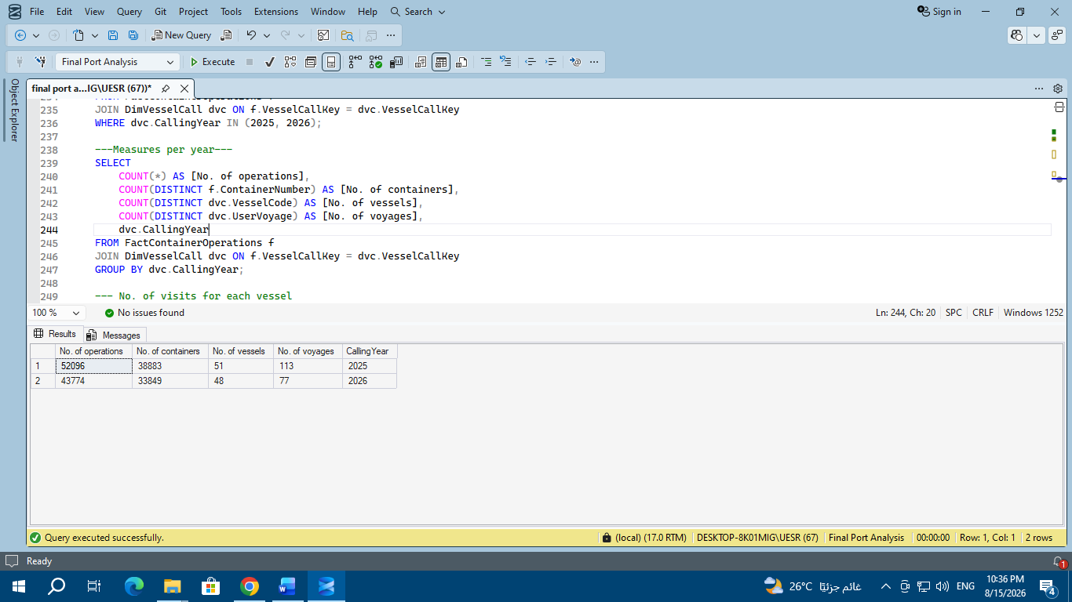

From the last two queries, we know the number of operations, containers, vessels, and voyages for the two years together (2025 and 2026) and for each year individually.

*Overall Summary (Combined 2025–2026)
- Total Operations (No. of operations): 95,870 container operations were processed.
- Unique Containers (No. of containers): 67,738 distinct containers passed through the port.
- Unique Vessels (No. of vessels): 81 individual vessels visited the port.
- Total Voyages (No. of voyages): 190 ship voyages were recorded in total.

*Year-over-Year Breakdown & Comparison
Metric | Year 2025 | Year 2026 | Analysis / Trend
No. of Operations | 52,096 | 43,774 | ~16% drop in overall port operations in 2026.
No. of Containers | 38,883 | 33,849 | ~13% decline in unique container volume in 2026.
No. of Vessels | 51 | 48 | Highly stable vessel diversity (most vessels returned both years).
No. of Voyages | 113 | 77 | ~32% reduction in total voyage frequency in 2026.

*Strategic Business Insights
- Handling Efficiency per Container:
  - 2025: $52,096÷38,883≈1.34$ operations per container.
  - 2026: $43,774÷33,849≈1.29$ operations per container.
  - Insight: The average handling intensity per container remained consistent across both years.
- Vessel Call Frequency (Voyages per Vessel):
  - 2025: Ships averaged 2.2 visits per year ($113÷51$).
  - 2026: Ships averaged 1.6 visits per year ($77÷48$).
  - Insight: Individual vessels called at the port less frequently in 2026 compared to 2025.

- No. of visits for each vessel
SELECT
dvc.VesselName,
dvc.VesselCode,
COUNT(DISTINCT dvc.UserVoyage) AS [Number of visits]
FROM FactContainerOperations f
JOIN DimVesselCall dvc ON f.VesselCallKey = dvc.VesselCallKey
GROUP BY dvc.VesselCode, dvc.VesselName
ORDER BY [Number of visits] DESC;
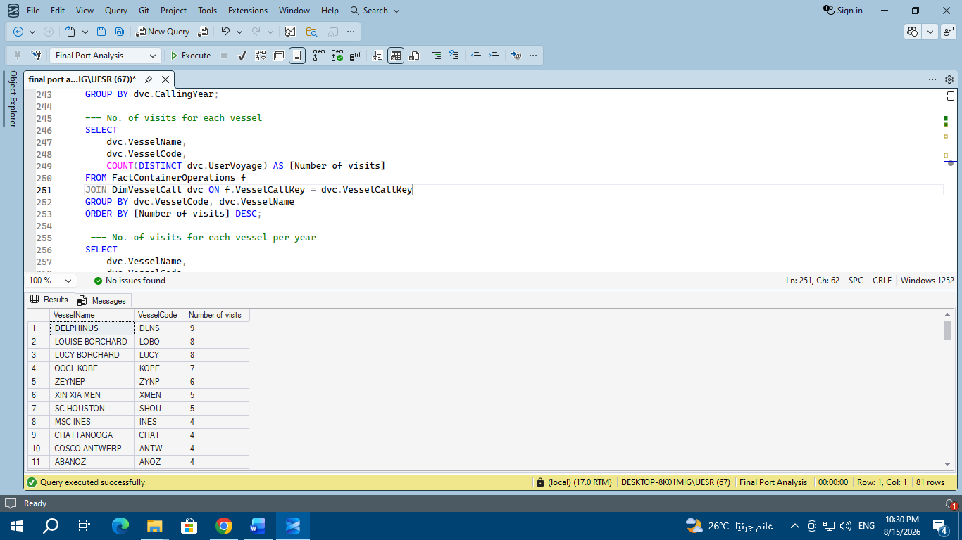
- No. of visits for each vessel per year

SELECT
dvc.VesselName,
dvc.VesselCode,
COUNT(DISTINCT dvc.UserVoyage) AS [Number of visits],
dvc.CallingYear
FROM FactContainerOperations f
JOIN DimVesselCall dvc ON f.VesselCallKey = dvc.VesselCallKey
GROUP BY dvc.CallingYear, dvc.VesselCode, dvc.VesselName
ORDER BY dvc.CallingYear ASC, [Number of visits] DESC
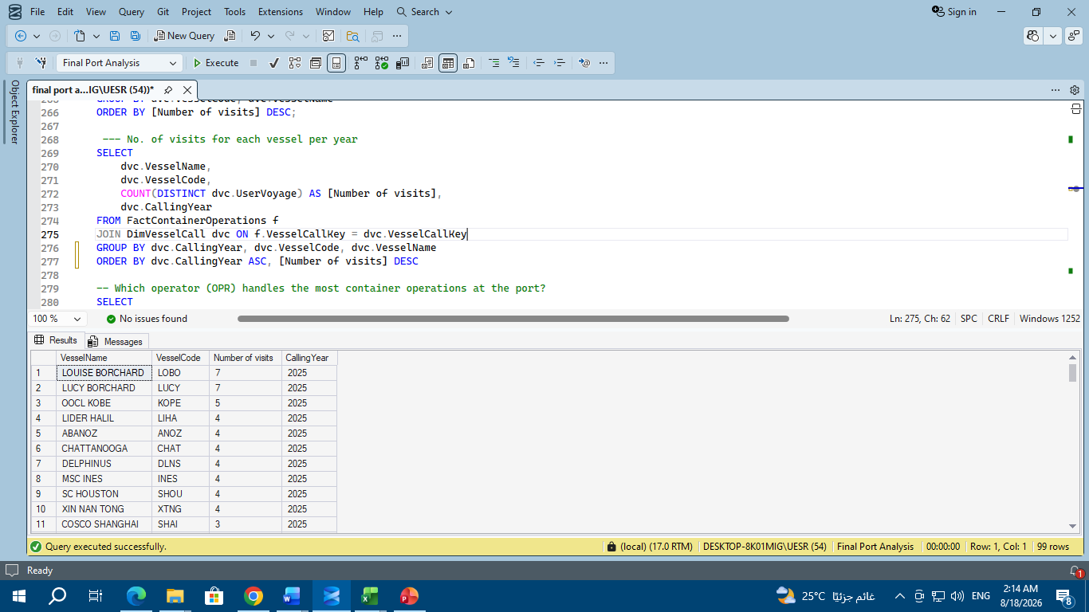

*Most Frequent Vessels Overall:
- DELPHINUS (DLNS): Rank #1 most frequent ship overall with 9 total visits.
- LOUISE BORCHARD (LOBO) & LUCY BORCHARD (LUCY): Tied for 2nd place with 8 total visits each.
- OOCL KOBE (KOPE): Recorded 7 total visits.
- ZEYNEP (ZYNP): Recorded 6 total visits.

*Top Frequent Vessels Per Year:
- Year 2025:
  - LOUISE BORCHARD and LUCY BORCHARD dominated port activity with 7 visits each.
  - Followed by OOCL KOBE with 5 visits.
- Year 2026:
  - DELPHINUS became the top-visiting vessel in 2026 with 5 visits (up from 4 visits in 2025).
  - Followed by vessels like S.KUZNETSOV and ZEYNEP with 4 visits each.

- Which operator (OPR) handles the most container operations at the port?
SELECT
OperatorCode,
COUNT(*) AS [No. of container operations]
FROM (
SELECT DISTINCT
f.ContainerNumber,
dvc.UserVoyage,
dop.OperatorCode
FROM FactContainerOperations f
JOIN DimVesselCall dvc ON f.VesselCallKey = dvc.VesselCallKey
JOIN DimOperator dop ON f.OperatorKey = dop.OperatorKey
) AS [Unique container operations]
GROUP BY OperatorCode
ORDER BY [No. of container operations] DESC;

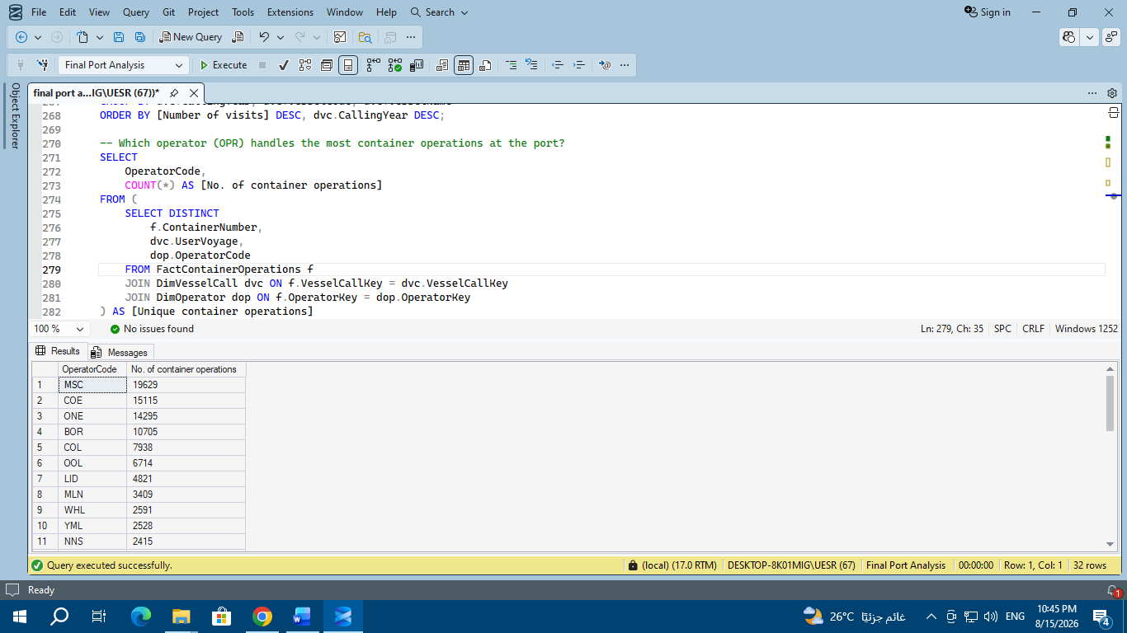

- Which operator (OPR) handles the most container operations at the port for each year?
SELECT
OperatorCode,
COUNT(*) AS [No. of container operations],
CallingYear
FROM (
SELECT DISTINCT
f.ContainerNumber,
dvc.UserVoyage,
dop.OperatorCode,
dvc.CallingYear
FROM FactContainerOperations f
JOIN DimVesselCall dvc ON f.VesselCallKey = dvc.VesselCallKey
JOIN DimOperator dop ON f.OperatorKey = dop.OperatorKey
) AS [Unique container operations]
GROUP BY OperatorCode, CallingYear
ORDER BY CallingYear, [No. of container operations] DESC;

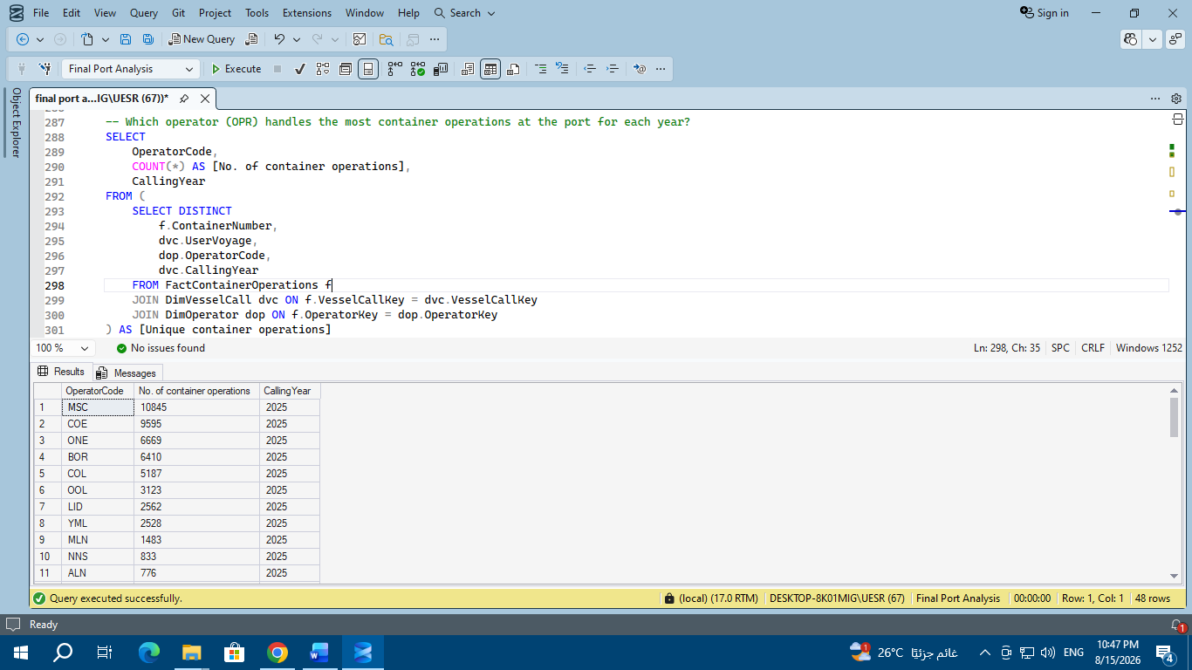

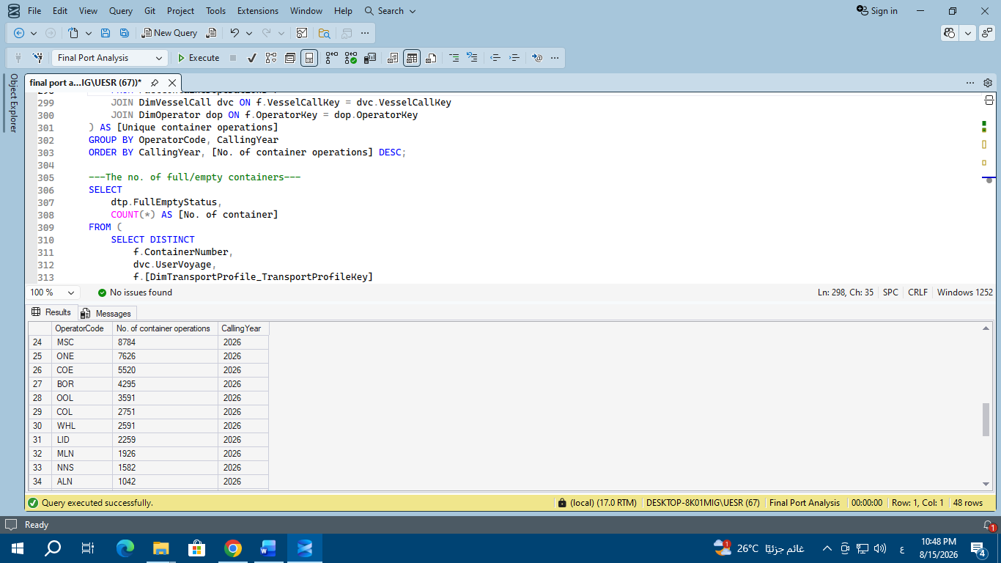

*Top Operators Overall:
- MSC: Leads as the dominant operator by a wide margin with 19,629 total container operations.
- COE: Ranks 2nd with 15,115 operations.
- ONE: Ranks 3rd with 14,295 operations.
- BOR: Ranks 4th with 10,705 operations.
- Secondary operators include COL (7,938), OOL (6,714), and LID (4,821).

*Top 4 Operators Comparison Summary (2025 vs 2026):

Operator | 2025  Ops | 2026 Ops | Combined Total | 2025 Rank | 2026 Rank
MSC | 10,845 | 8,784 | 19,629 | 1st | 1st
COE | 9,595 | 5,520 | 15,115 | 2nd | 3rd
ONE | 6,669 | 7,626 | 14,295 | 3rd | 2nd
BOR | 6,410 | 4,295 | 10,705 | 4th | 4th

- The no. of full/empty containers

SELECT
c.CallingYear AS Year,
dtp.FullEmptyStatus,
COUNT(*) AS [No. of container]
FROM (
SELECT DISTINCT
f.ContainerNumber,
dvc.UserVoyage,
dvc.CallingYear,
f.[DimTransportProfile_TransportProfileKey]
FROM FactContainerOperations f
JOIN DimVesselCall dvc
ON f.VesselCallKey = dvc.VesselCallKey
) AS c
JOIN DimTransportProfile dtp
ON c.[DimTransportProfile_TransportProfileKey] = dtp.TransportProfileKey
GROUP BY
c.CallingYear,
dtp.FullEmptyStatus
ORDER BY
c.CallingYear,
dtp.FullEmptyStatus; 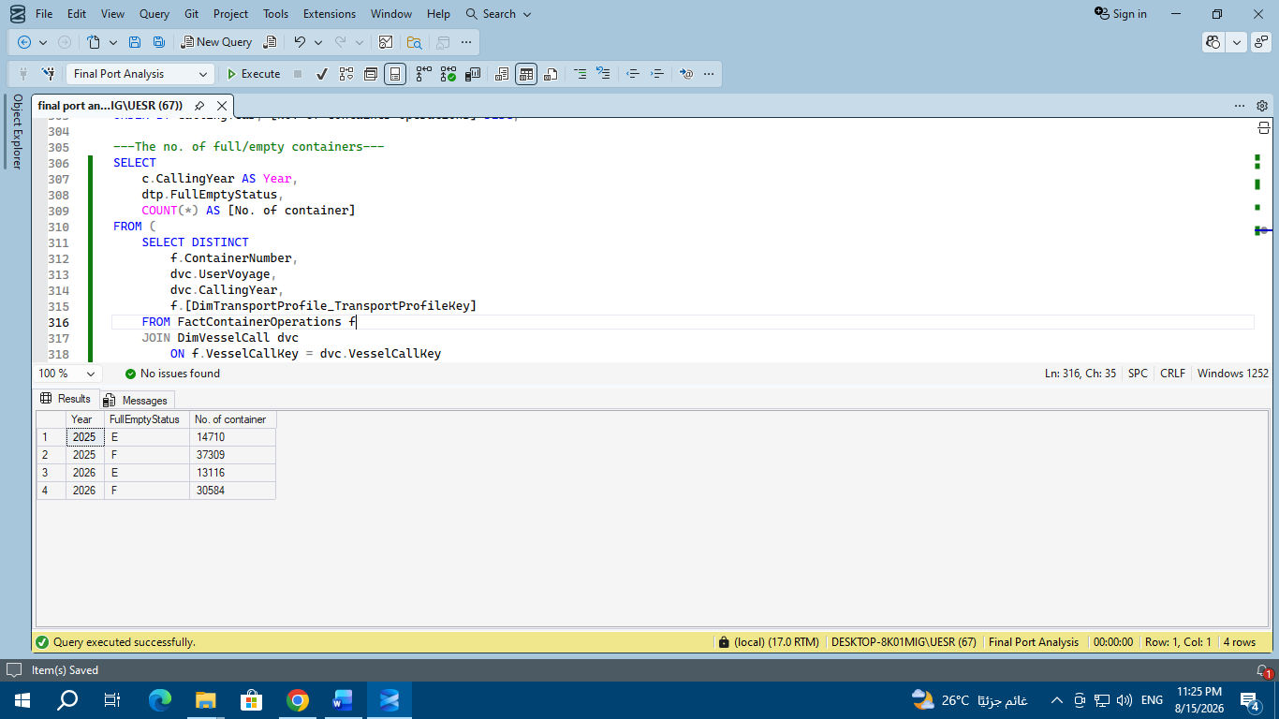

- Year 2025:
  - Full Containers (F): 37,309 units (~71.7% of total volume).
  - Empty Containers (E): 14,710 units (~28.3% of total volume).
- Year 2026:
  - Full Containers (F): 30,584 units (~70.0% of total volume).
  - Empty Containers (E): 13,116 units (~30.0% of total volume).
Key Insights:
- Stable Full-to-Empty Ratio: The share of loaded/full containers remained remarkably stable at around 70%–72% across both years.
- Overall Volume Shift: Loaded (F) container volume decreased by ~18% in 2026, while empty (E) container handling saw a smaller drop of ~10.8%.

- The most commodities imported and exported
SELECT
dc.Commodity,
dtp.Mode,
COUNT(*) AS [No. of operations]
FROM FactContainerOperations f
JOIN DimCargo dc ON f.[DimCargo_CargoKey] = dc.CargoKey
JOIN DimTransportProfile dtp ON f.[DimTransportProfile_TransportProfileKey] = dtp.TransportProfileKey
GROUP BY dc.Commodity, dtp.Mode
ORDER BY dtp.Mode, [No. of operations] DESC;

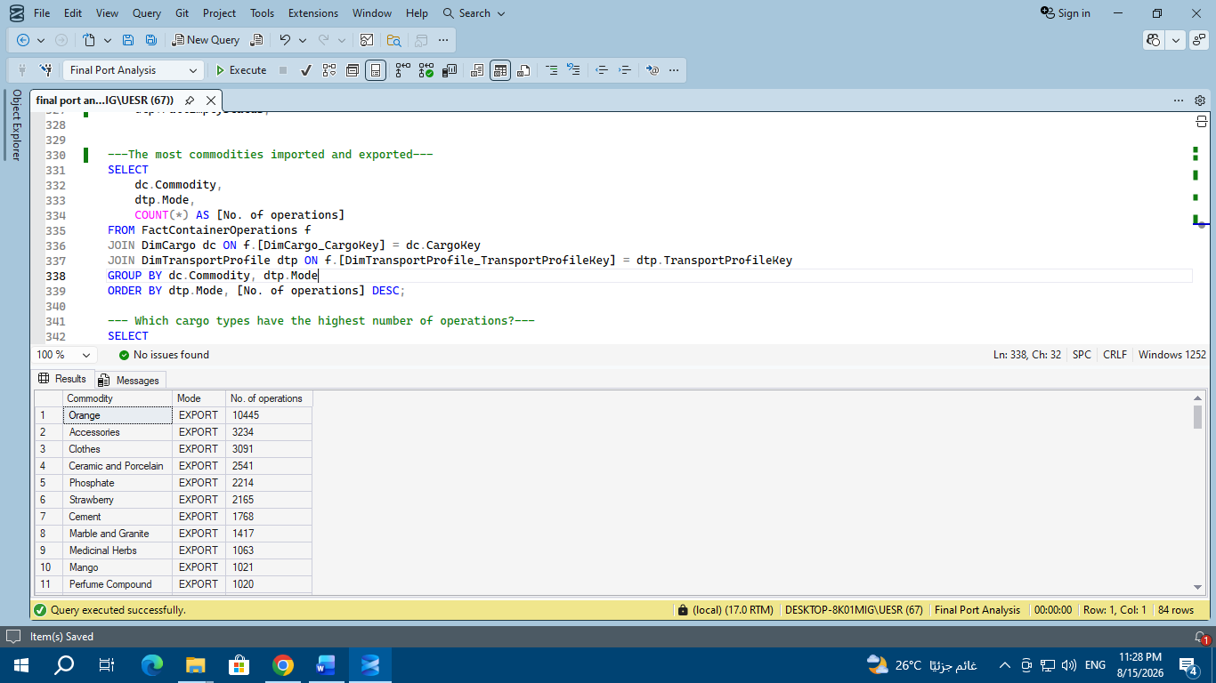

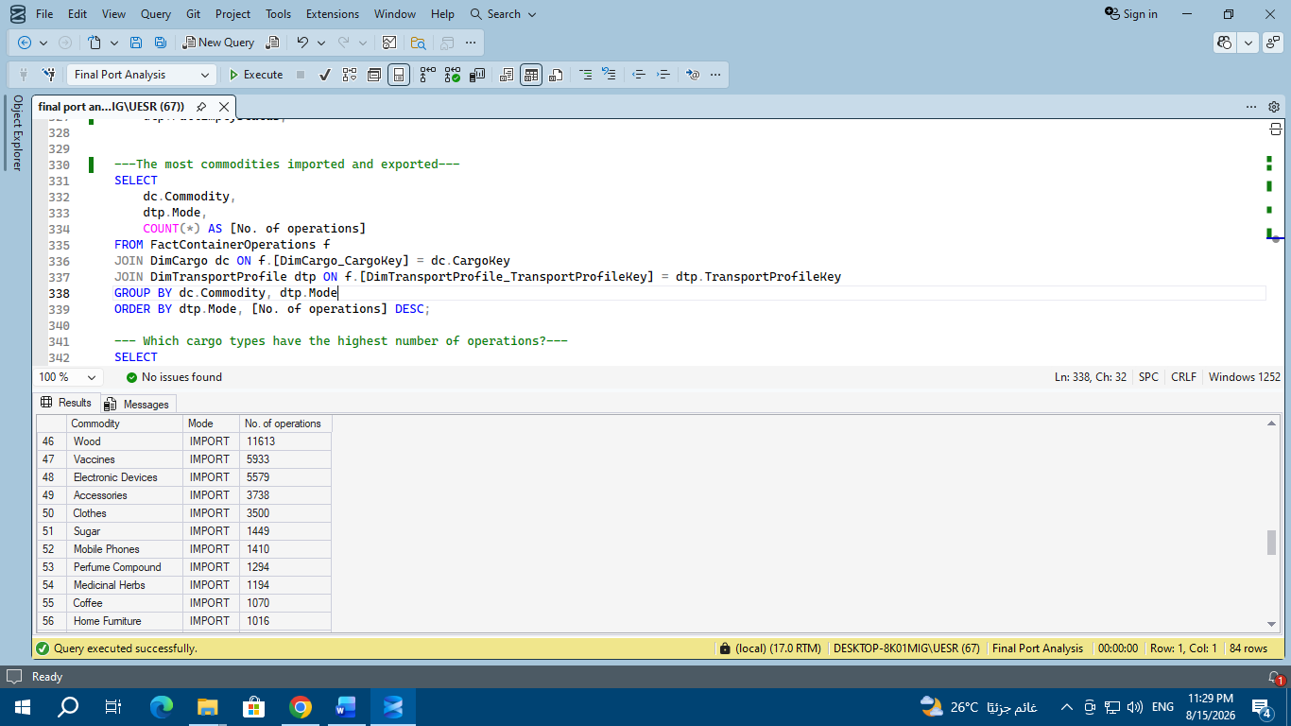
Top Exported Commodities
- Orange: Dominates exports by a massive margin with 10,445 operations, making it the primary agricultural export.
- Accessories: Ranks 2nd with 3,234 operations.
- Clothes: Ranks 3rd with 3,091 operations.
- Ceramic and Porcelain: Ranks 4th with 2,541 operations.
- Phosphate & Strawberry: Follow with 2,214 and 2,165 operations respectively.

Top Imported Commodities
- Wood: Leads all imported commodities with an outstanding 11,613 operations (the highest single commodity volume overall).
- Vaccines: Holds 2nd place with 5,933 operations.
- Electronic Devices: Holds 3rd place with 5,579 operations.
- Accessories & Clothes: Follow closely with 3,738 and 3,500 import operations respectively.
Key Strategic Insights:
- Primary Trade Drivers: Imported Wood (11,613) and Exported Oranges (10,445) represent the main cargo drivers for the port.
- Bi-directional Commodities: Items like Accessories and Clothes show high volume in both import and export streams, suggesting significant re-export or raw-material-to-finished-goods processing activity.

- The most commodities imported and exported for each year
SELECT
dvc.CallingYear AS Year,
dc.Commodity,
dtp.Mode,
COUNT(*) AS [No. of operations]
FROM FactContainerOperations f
JOIN DimCargo dc
ON f.[DimCargo_CargoKey] = dc.CargoKey
JOIN DimTransportProfile dtp
ON f.[DimTransportProfile_TransportProfileKey] = dtp.TransportProfileKey
JOIN DimVesselCall dvc
ON f.VesselCallKey = dvc.VesselCallKey
GROUP BY
dvc.CallingYear,
dc.Commodity,
dtp.Mode
ORDER BY
dvc.CallingYear,
dtp.Mode,
[No. of operations] DESC;
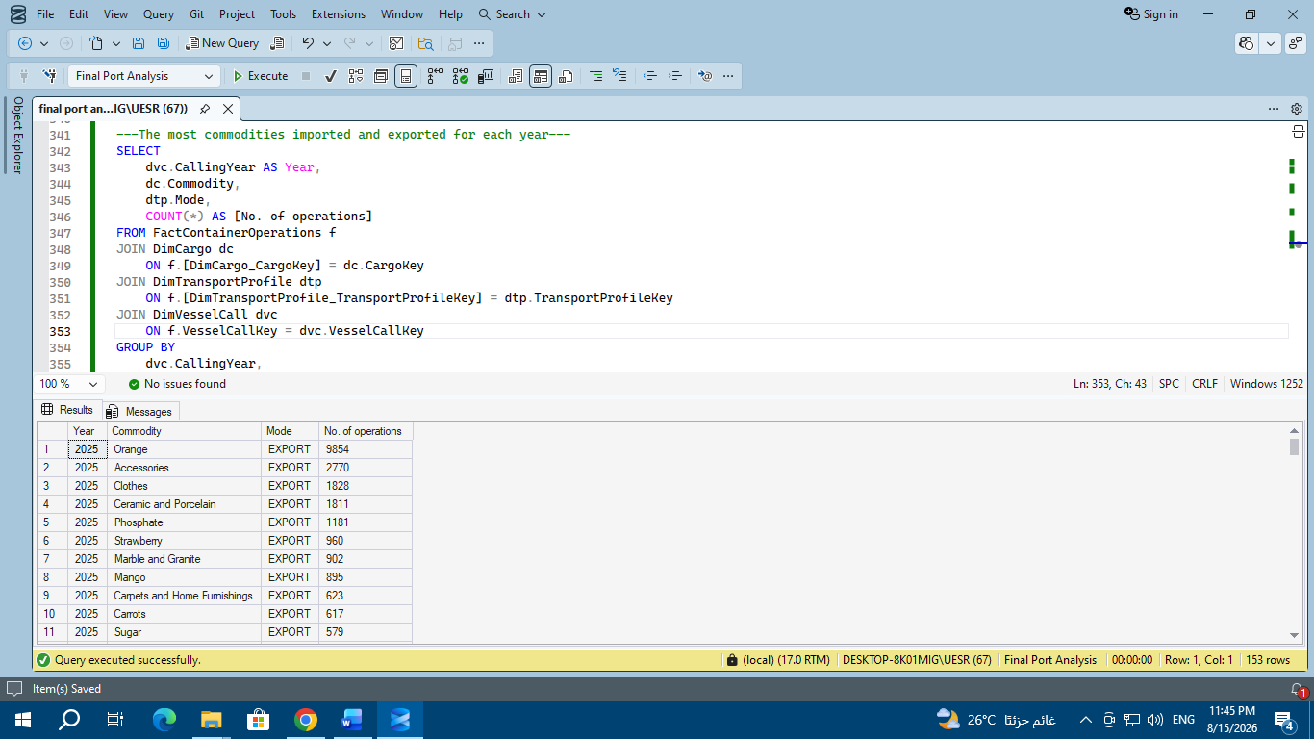
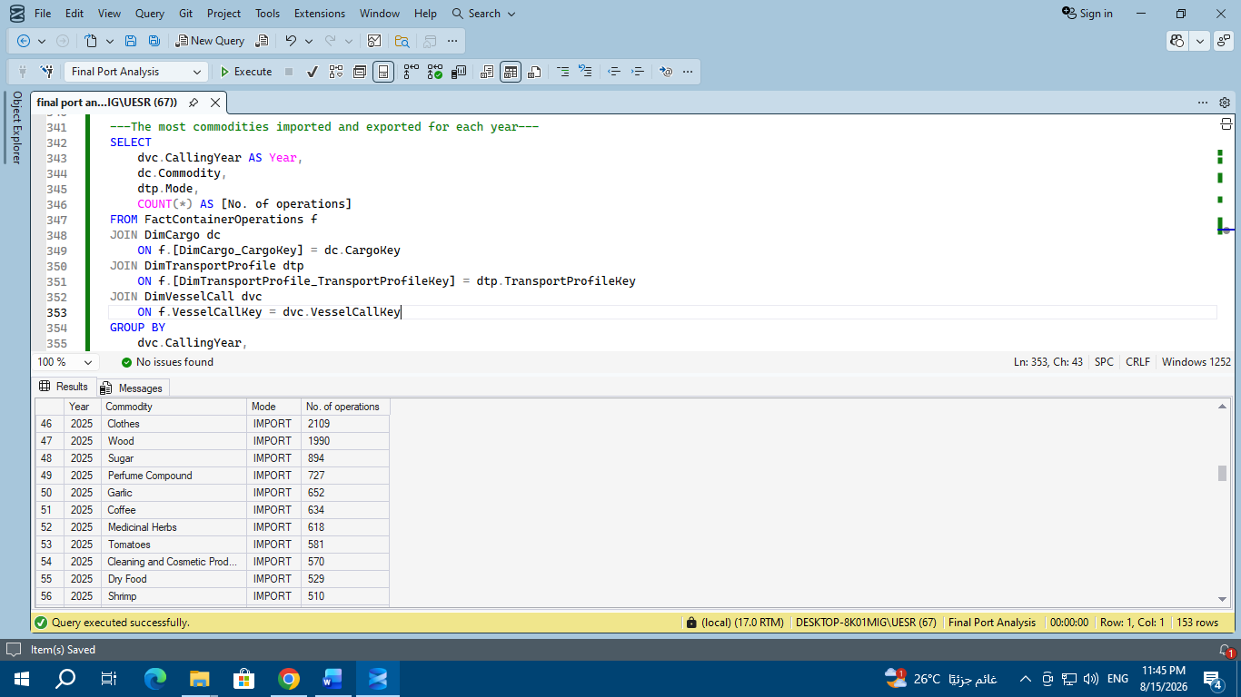
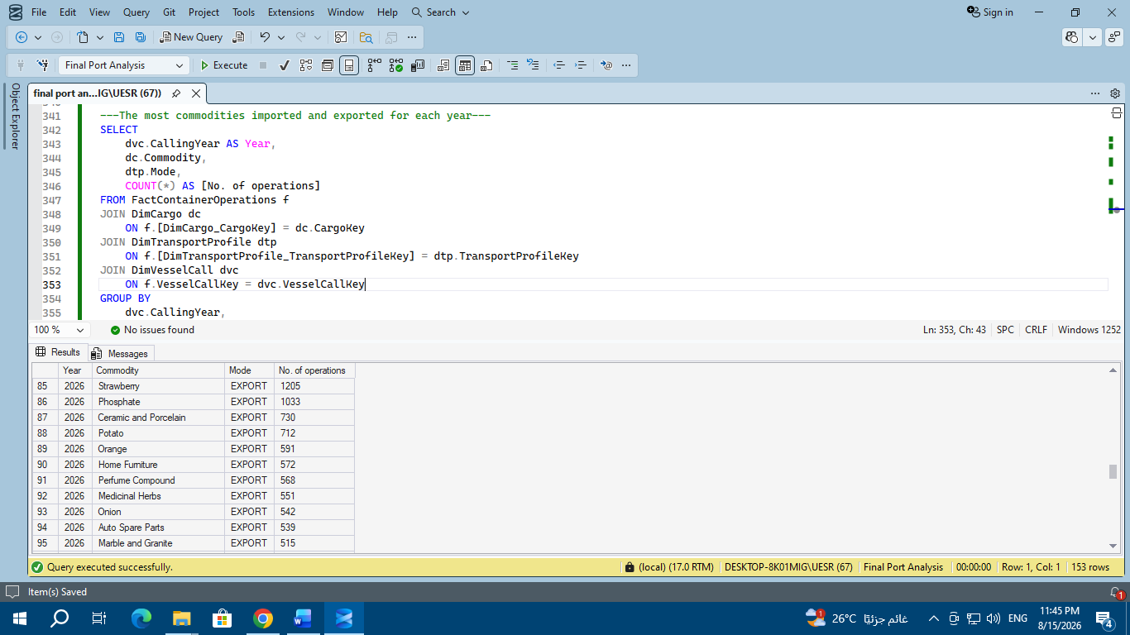
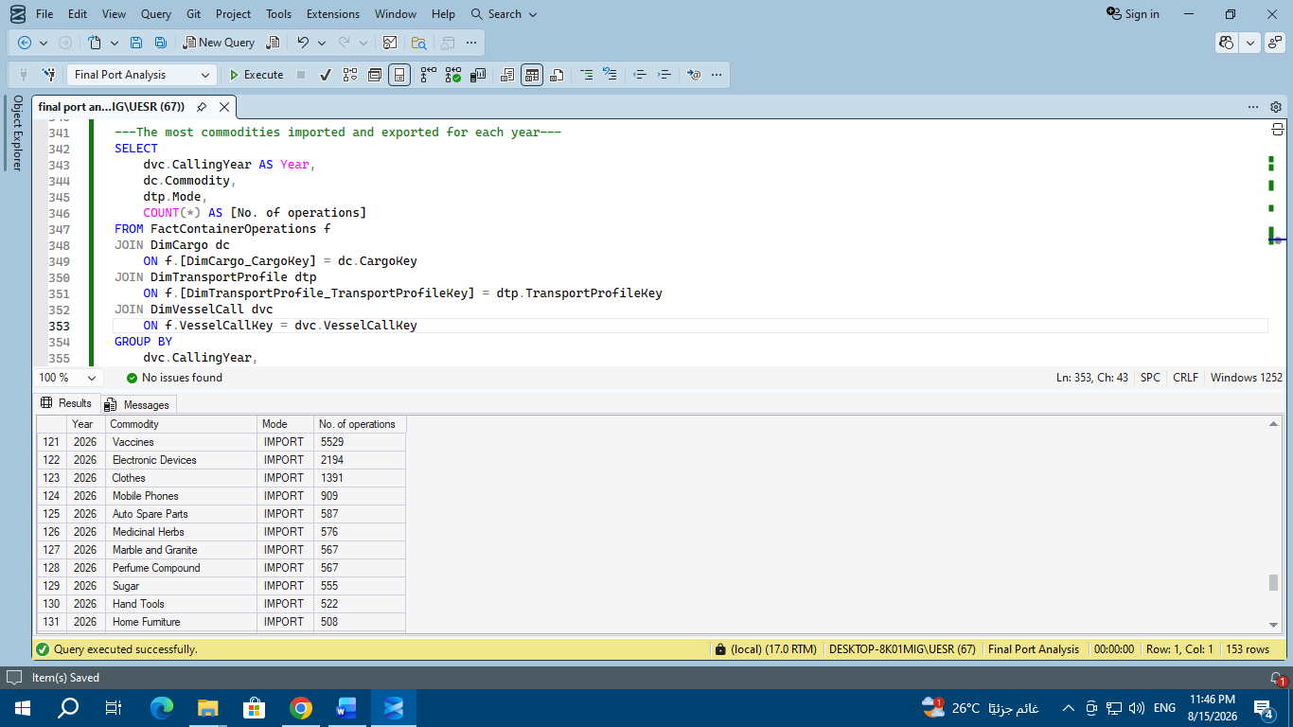

Export Dynamics:
- 2025: Dominated by Orange exports with a massive 9,854 operations, followed by Accessories (2,770) and Clothes (1,828).
- 2026: Agricultural export focus shifted; Strawberry became the #1 export with 1,205 operations, followed by Phosphate (1,033) and Ceramics (730), while Orange exports dropped sharply to 591 operations.

Import Dynamics:
- 2025: Led by Clothes (2,109 operations) and Wood (1,990 operations).
- 2026: High demand shifted toward healthcare and tech; Vaccines surged to #1 import with 5,529 operations, followed by Electronic Devices (2,194 operations).

- Which cargo types have the highest number of operations?
SELECT
dc.CargoType,
COUNT(*) AS [No. of operations]
FROM FactContainerOperations f
JOIN DimCargo dc ON f.[DimCargo_CargoKey] = dc.CargoKey
GROUP BY dc.CargoType
ORDER BY [No. of operations] DESC;
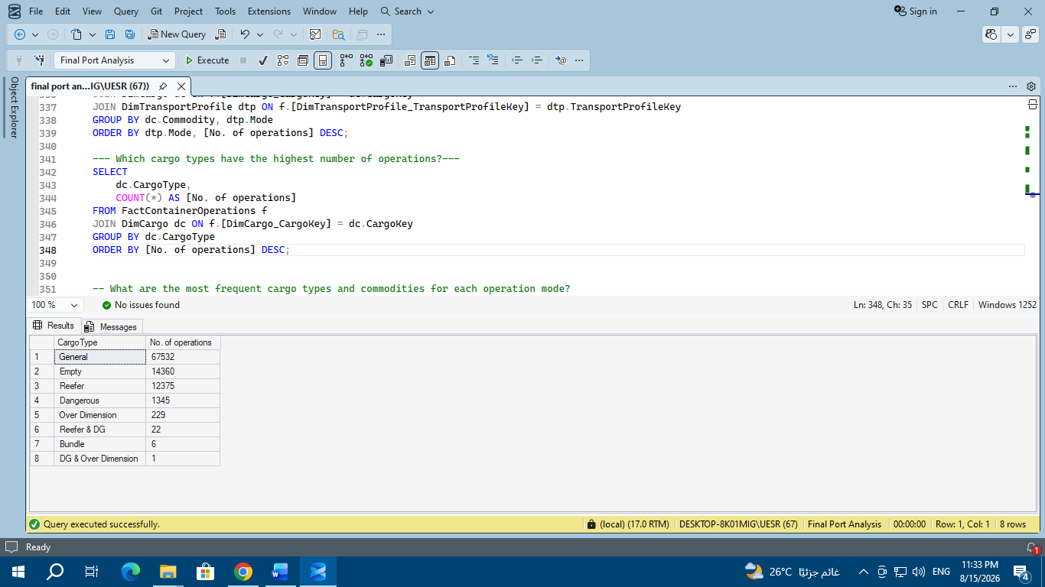
- General Cargo: Dominates the port operations with 67,532 operations (~70.4% of total volume).
- Empty Containers: Ranks 2nd with 14,360 operations (~15.0%).
- Reefer Containers: Ranks 3rd with 12,375 operations (~12.9%), serving temperature-sensitive goods like oranges, strawberries, and vaccines.
- Dangerous (DG) Cargo: Recorded 1,345 operations (~1.4%).
- Over Dimension Cargo: Recorded 229 operations.
- Special/Hybrid Categories:
  - Reefer & DG: 22 operations.
  - Bundle: 6 operations.
  - DG & Over Dimension: Only 1 operation.
Strategic Insights:
- Core Operational Focus: General cargo and refrigerated containers (Reefer) form the backbone of the port's operations.
- Niche Volume: Specialized cargo types like dangerous goods and oversized equipment represent a very small fraction of the total traffic, indicating the port primarily serves general commercial and agricultural trade flows.

- What are the most frequent cargo types and commodities for each operation mode?
SELECT
COUNT(*) AS [No. of operations],
dc.CargoType,
dc.Commodity,
dcs.ContainerType,
dtp.Mode
FROM FactContainerOperations f
JOIN DimCargo dc ON f.[DimCargo_CargoKey] = dc.CargoKey
JOIN DimContainerSpecification dcs ON f.ContainerSpecificationKey dcs.ContainerSpecificationKey
JOIN DimTransportProfile dtp ON f.[DimTransportProfile_TransportProfileKey] = dtp.TransportProfileKey
WHERE dc.CargoType <> 'Empty'
OR dc.CargoType IS NULL
GROUP BY dc.CargoType, dc.Commodity, dcs.ContainerType, dtp.Mode
ORDER BY dtp.Mode, [No. of operations] DESC;
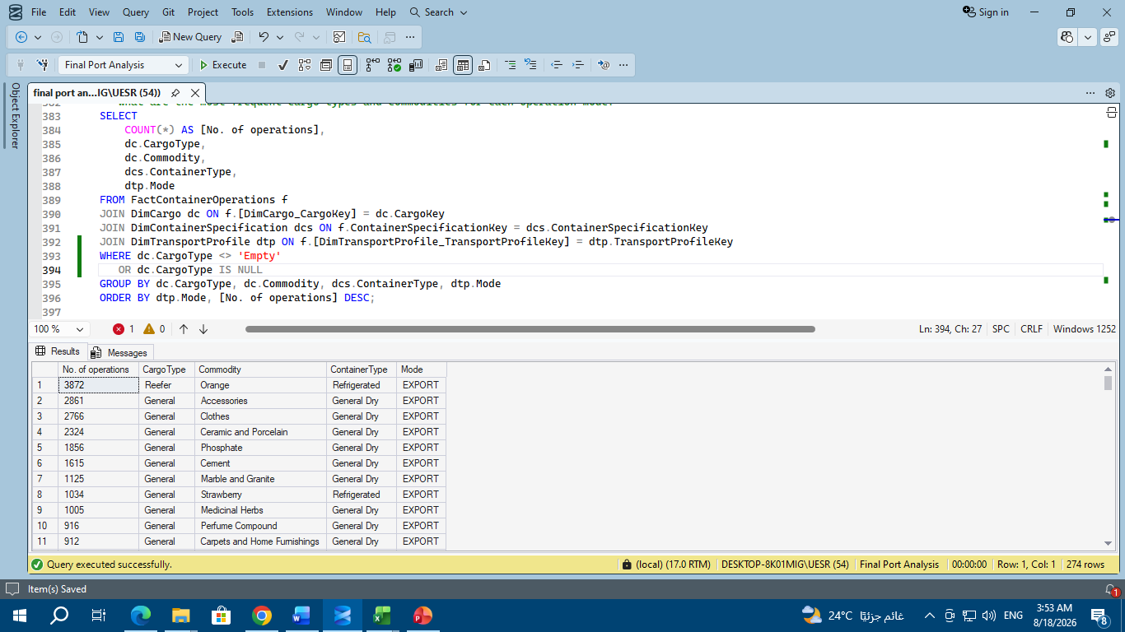

Refrigerated & Agricultural Exports:
- Empty Refrigerated Containers for Export: Recorded 5,999 operations, representing empty reefer repositioning to support agricultural exports.
- Exported Oranges (Orange + Reefer): Accounted for 3,872 operations in refrigerated containers.
- Exported Strawberries (Strawberry): Recorded 1,034 operations in refrigerated containers.

General Dry Cargo Exports:
- Accessories: 2,861 export operations using General Dry containers.
- Clothes: 2,766 export operations.
- Ceramic and Porcelain: 2,324 export operations.
- Phosphate: 1,856 export operations.
- Cement: 1,615 export operations.
- Marble and Granite: 1,125 export operations.

Strategic Insights:
- Container-Cargo Alignment: Clear 1:1 operational mapping where perishable goods (Oranges, Strawberries) exclusively utilize Refrigerated containers, while manufactured/industrial goods use General Dry containers.
- High Cold-Chain Demand: The substantial volume of empty reefer containers (5,999) highlights a strong cold-chain logistics requirement to serve export markets

- Which loading ports have the highest number of container operations?
SELECT
dpol.POLCode,
COUNT(*) AS [No. of container operations]
FROM (
SELECT DISTINCT
dvc.UserVoyage,
f.ContainerNumber,
f.[DimPortPOL_POLKey]
FROM FactContainerOperations f
JOIN DimVesselCall dvc ON f.VesselCallKey = dvc.VesselCallKey
) AS c
JOIN DimPortPOL dpol ON c.[DimPortPOL_POLKey] = dpol.POLKey
GROUP BY dpol.POLCode
ORDER BY [No. of container operations] DESC;

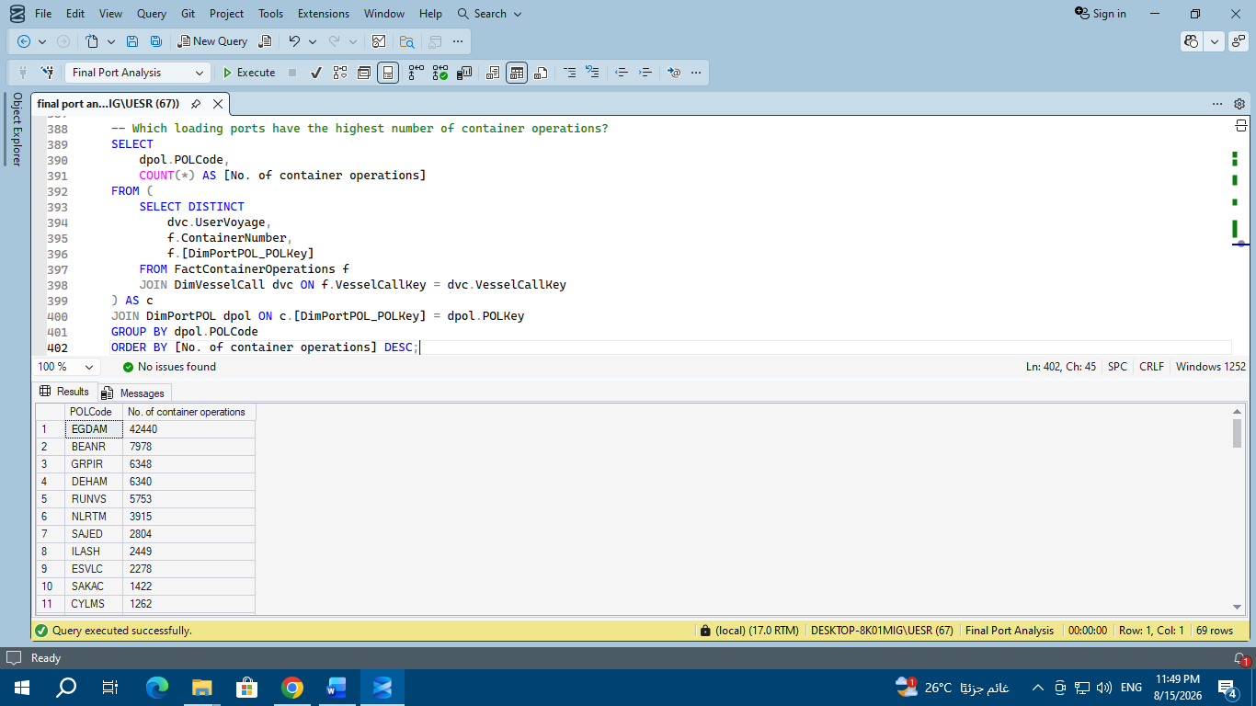

- What are the loading ports with the highest number of unique container operations? And in which country and region are they located?
SELECT
c.CallingYear AS Year,
dpol.POLCode,
COUNT(*) AS [No. of container operations],
dpol.[PortMaster_PortName] AS PortName,
dpol.[PortMaster_Country] AS Country,
dpol.[PortMaster_Region] AS Region
FROM (
SELECT DISTINCT
dvc.UserVoyage,
dvc.CallingYear,
f.ContainerNumber,
f.[DimPortPOL_POLKey],
f.[DimTransportProfile_TransportProfileKey]
FROM FactContainerOperations f
JOIN DimVesselCall dvc
ON f.VesselCallKey = dvc.VesselCallKey
) AS c
JOIN DimPortPOL dpol
ON c.[DimPortPOL_POLKey] = dpol.POLKey
JOIN DimTransportProfile dtp
ON c.[DimTransportProfile_TransportProfileKey] = dtp.TransportProfileKey
GROUP BY
c.CallingYear,
dpol.POLCode,
dpol.[PortMaster_PortName],
dpol.[PortMaster_Country],
dpol.[PortMaster_Region]
ORDER BY
c.CallingYear,
[No. of container operations] DESC;
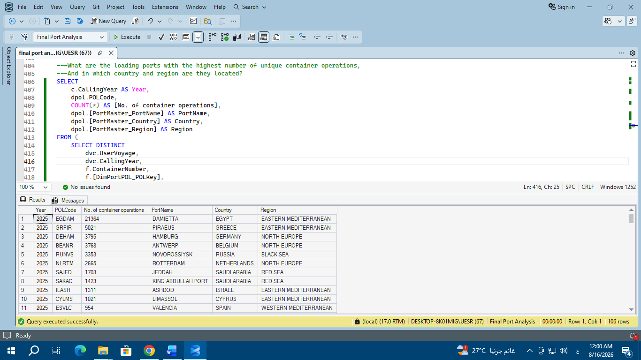
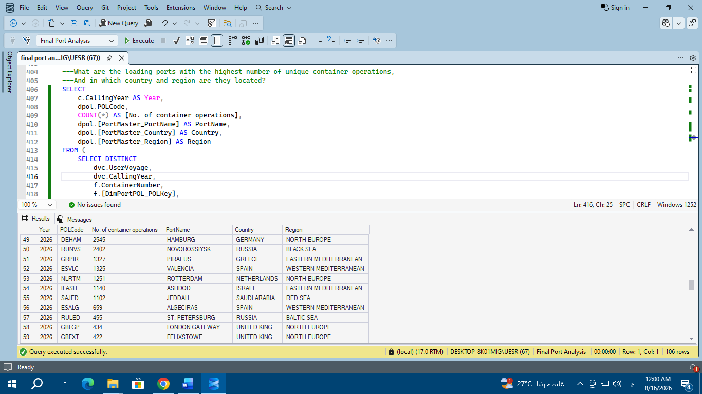
- 2025 POL Operations
  - Damietta (DAMIETTA - Egypt): Dominates with 21,364 operations.
  - Piraeus (PIRAEUS - Greece): Ranks 2nd with 5,021 operations.
  - Hamburg (HAMBURG - Germany): Ranks 3rd with 3,795 operations.
  - Antwerp (ANTWERP - Belgium): Ranks 4th with 3,768 operations.
- 2026 POL Operations
  - Hamburg (HAMBURG - Germany): Leads with 2,545 operations.
  - Novorossiysk (NOVOROSSIYSK - Russia): Holds 2nd place with 2,402 operations.
  - Piraeus (PIRAEUS - Greece): Ranks 3rd with 1,327 operations.

- Which discharging ports have the highest number of container operations?
SELECT
dpod.PODCode,
COUNT(*) AS [No. of container operations]
FROM (
SELECT DISTINCT
dvc.UserVoyage,
f.ContainerNumber,
f.PODKey
FROM FactContainerOperations f
JOIN DimVesselCall dvc ON f.VesselCallKey = dvc.VesselCallKey
) AS c
JOIN DimPortPOD dpod ON c.PODKey = dpod.PODKey
GROUP BY dpod.PODCode
ORDER BY [No. of container operations] DESC;

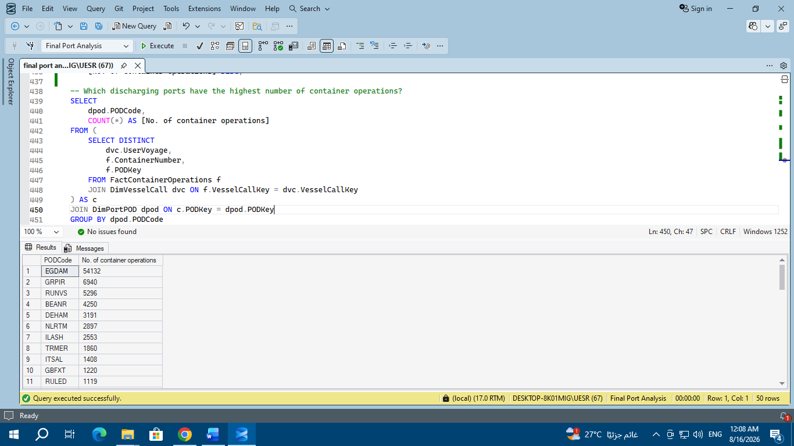

- What are the destination/discharge ports with the highest number of unique container operations? And in which country and region are they located?
SELECT
c.CallingYear AS Year,
dpod.PODCode,
COUNT(*) AS [No. of container operations],
dpod.[POD_Master_PortName] AS PortName,
dpod.[POD_Master_Country] AS Country,
dpod.Region
FROM (
SELECT DISTINCT
dvc.UserVoyage,
dvc.CallingYear,
f.ContainerNumber,
f.PODKey
FROM FactContainerOperations f
JOIN DimVesselCall dvc
ON f.VesselCallKey = dvc.VesselCallKey
) AS c
JOIN DimPortPOD dpod
ON c.PODKey = dpod.PODKey
GROUP BY
c.CallingYear,
dpod.PODCode,
dpod.[POD_Master_PortName],
dpod.[POD_Master_Country],
dpod.Region
ORDER BY
c.CallingYear,
[No. of container operations] DESC;
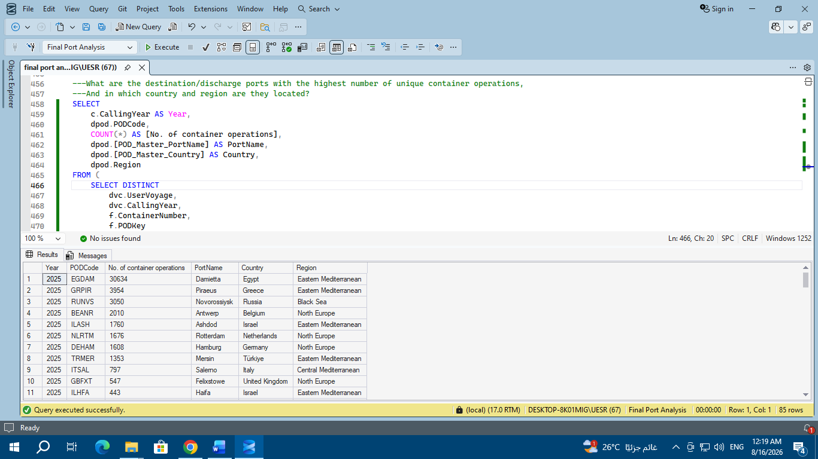
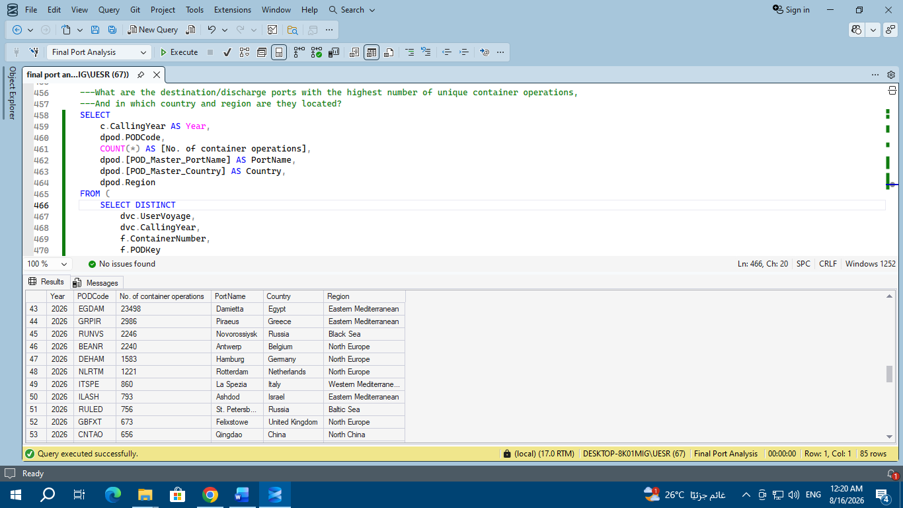

Overall Discharging Ports (POD) Summary
- Damietta (EGDAM - Egypt): Dominates overall discharging operations with 54,132 unique container operations.
- Piraeus (GRPIR - Greece): Holds 2nd place with 6,940 operations.
- Novorossiysk (RUNVS - Russia): Ranks 3rd with 5,296 operations.
- Antwerp (BEANR - Belgium): Ranks 4th with 4,250 operations.
- Hamburg (DEHAM - Germany): Ranks 5th with 3,191 operations.
Year-over-Year Breakdown (2025 vs. 2026)
- 2025 Top Discharging Ports:
  - Damietta (EGDAM): 30,634 operations.
  - Piraeus (GRPIR): 3,954 operations.
  - Novorossiysk (RUNVS): 3,050 operations.
  - Antwerp (BEANR): 2,010 operations.
  - Ashdod (ILASH): 1,760 operations.
- 2026 Top Discharging Ports:
  - Damietta (EGDAM): Maintains lead with 23,498 operations.
  - Piraeus (GRPIR): 2,986 operations.
  - Novorossiysk (RUNVS): 2,246 operations.
  - Antwerp (BEANR): 2,240 operations.
  - La Spezia (ITSPE): Enters top rankings with 860 operations (Western Mediterranean).
  - Qingdao (CNTAO): Appears in 2026 with 656 operations (North China).
Key Logistics Insights
- Regional Dominance: The Eastern Mediterranean region (driven primarily by Damietta) accounts for the vast majority of discharging traffic.
- Route Consistency: The top four ports—Damietta, Piraeus, Novorossiysk, and Antwerp—remain identical across both 2025 and 2026, indicating stable core trade lanes.
- Geographic Expansion: Data for 2026 reflects broader connectivity, introducing ports in North China (Qingdao) and Western Mediterranean (La Spezia)

Comprehensive POL vs. POD Comparison Table
Port (Code / Country) | 2025 POL | 2025 POD | 2026 POL | 2026 POD | Net Operational Profile
Damietta (EGDAM / EG) | 21,364 | 30,634 | 21,122 | 23,498 | Heavy Import / Discharge Hub
Piraeus (GRPIR / GR) | 5,021 | 3,954 | 1,327 | 2,986 | Balanced Transshipment Corridor
Novorossiysk (RUNVS / RU) | 3,353 | 3,050 | 2,402 | 2,246 | Symmetrical Gateway
Hamburg (DEHAM / DE) | 3,795 | 1,608 | 2,545 | 1,583 | Net Export Origin (POL > POD)
Antwerp (BEANR / BE) | 3,768 | 2,010 | 4,212 | 2,240 | Net Export Origin (POL > POD)
Rotterdam (NLRTM / NL) | 2,665 | 1,676 | 1,251 | 1,221 | Balanced Regional Hub

Key Analytical Insights
Trade Asymmetry (North Europe vs. Eastern Med):
  - North European Ports (BEANR, DEHAM): Consistently show significantly higher POL than POD counts, functioning primarily as cargo origins.
  - Eastern Mediterranean (EGDAM): Acts as the main primary destination/discharge terminal, absorbing high inflows from European origins.
2026 Operational Shift:
  - Global container activity experienced a general contraction from 2025 to 2026 across most primary Mediterranean hubs, while select North European export routes (BEANR POL) retained strong volume.
Emerging & Niche Destinations in 2026:
  - New minor discharge routes appeared in 2026 (e.g., MYPKG - Port Klang, Malaysia), indicating subtle route diversification toward Southeast Asia.

- How effectively is the container terminal utilizing its design capacity on a monthly basis? And what impact did early 2026 geopolitical events have on throughput trends?
“Terminal Capacity Utilization by month”

WITH teu_calc AS (
SELECT
FORMAT(f.InDateOnly, 'yyyy-MM') AS YearMonth,
dcs.TEUFactor AS TEU
FROM FactContainerOperations f
JOIN DimContainerSpecification dcs
ON f.ContainerSpecificationKey = dcs.ContainerSpecificationKey
WHERE f.InDateOnly IS NOT NULL
AND MONTH(f.InDateOnly) <= 3)
SELECT
YearMonth,
SUM(TEU) AS Actual_TEU,
500000 / 12.0 AS Design_Capacity_TEU_Monthly,
ROUND(
SUM(TEU) / (500000.0 / 12) * 100, 1) AS Utilization_Percentage
FROM teu_calc
GROUP BY YearMonth
ORDER BY YearMonth;
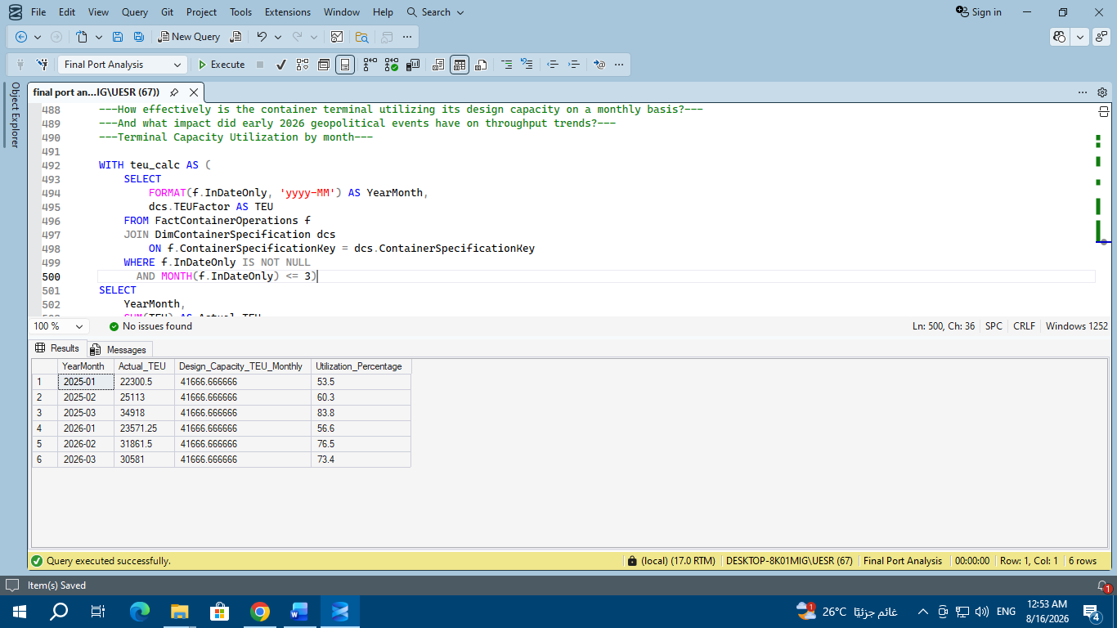
Insights:
Year-to-date operational growth (January and February):

Operation in January increased from 53.5% (2025) to 56.6% (2026).

February saw a significant jump in utilization from 60.3% (2025) to 76.5% (2026), with an increase in Actual TEU volumes of over 6,700 TEU.

Impact of geopolitical events in March 2026:

While March 2025 was the peak month with an utilization rate of 83.8% (34,918 TEU), the utilization rate in March 2026 decreased to 73.4% (30,581 TEU).

This 10.4% decrease reflects the direct impact of geopolitical events and shipping line disruptions at the beginning of 2026 on inbound and outbound cargo traffic at the terminal.

Overall Capacity Utilization Range:

The plant operates within a safe and stable range of 53% to 84% of its monthly design capacity of 41,666 TEU, meaning there is an operational surplus that allows for the accommodation of any future increase without reaching a bottleneck.

Impact of Supply Chain Disruptions:

Events that began in late February 2026 led to the rerouting of shipping vessels, cancellation of some voyages, and delays in container arrivals at ports in March.

Compared to March 2025, which saw growth of 31.7% compared to February 2025, March 2026 experienced a decrease of 7.9%, reflecting the direct impact of regional tensions and changes in shipping patterns.

- Quay Crane Productivity (Monthly) “What is the monthly productivity of the cranes?”
SELECT
FORMAT(f.InDateOnly, 'yyyy-MM') AS YearMonth,
de.EquipmentNumber AS Crane,
dvc.VesselCode,
dvc.CallingSequence AS Vessel_Call,
COUNT(f.ContainerNumber) AS Total_Moves,
SUM(DATEDIFF(SECOND, CAST('00:00:00' AS TIME), f.QCWorkingHoursSource)) / 3600.0 AS Total_Crane_Hours,
ROUND(COUNT(f.ContainerNumber) * 1.0 / NULLIF(SUM(DATEDIFF(SECOND,CAST('00:00:00' AS TIME), f.QCWorkingHoursSource)) / 3600.0,0),1) AS Avg_Moves_Per_Hour
FROM FactContainerOperations f
JOIN DimEquipment de
ON f.DimEquipment_EquipmentKey = de.EquipmentKey
JOIN DimVesselCall dvc
ON f.VesselCallKey = dvc.VesselCallKey
WHERE de.EquipmentNumber IS NOT NULL
AND de.EquipmentNumber <> ''
AND MONTH(f.InDateOnly) BETWEEN 1 AND 3
GROUP BY
FORMAT(f.InDateOnly, 'yyyy-MM'),
de.EquipmentNumber,
dvc.VesselCode,
dvc.CallingSequence
ORDER BY
YearMonth,
Crane;
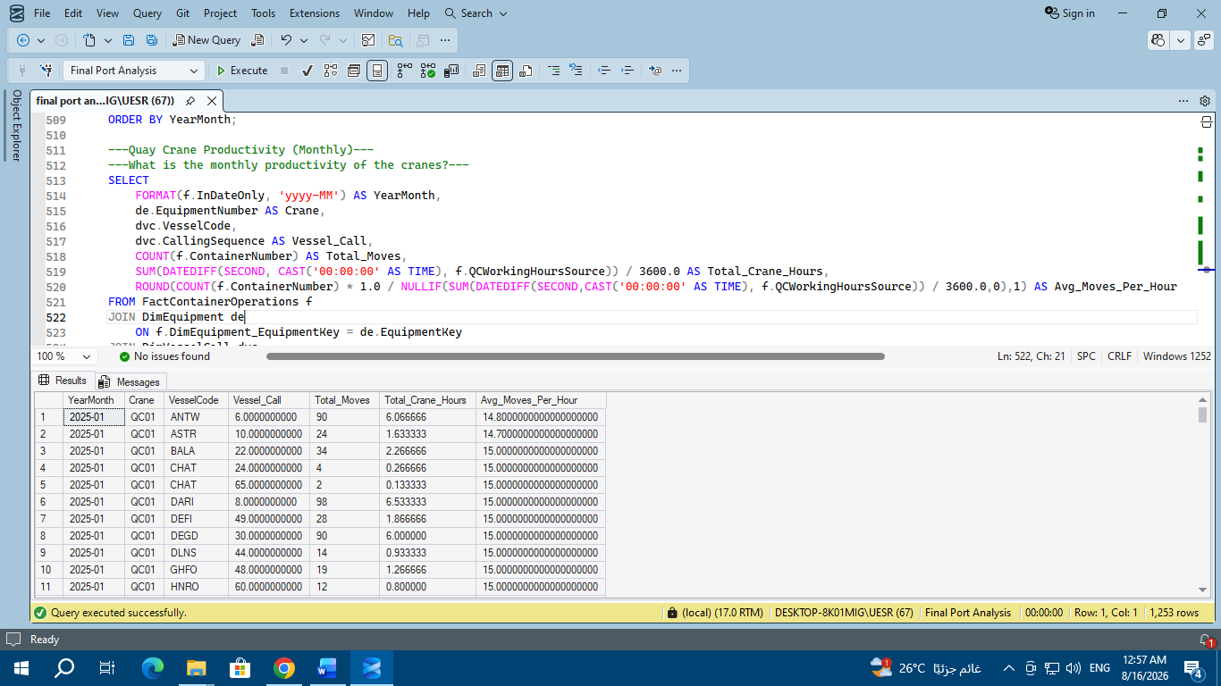
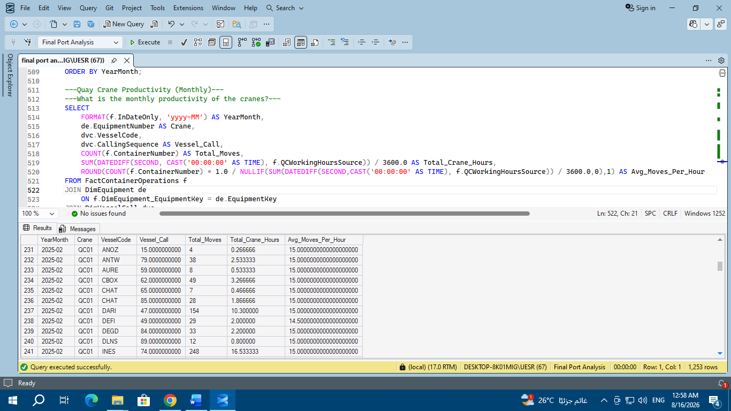
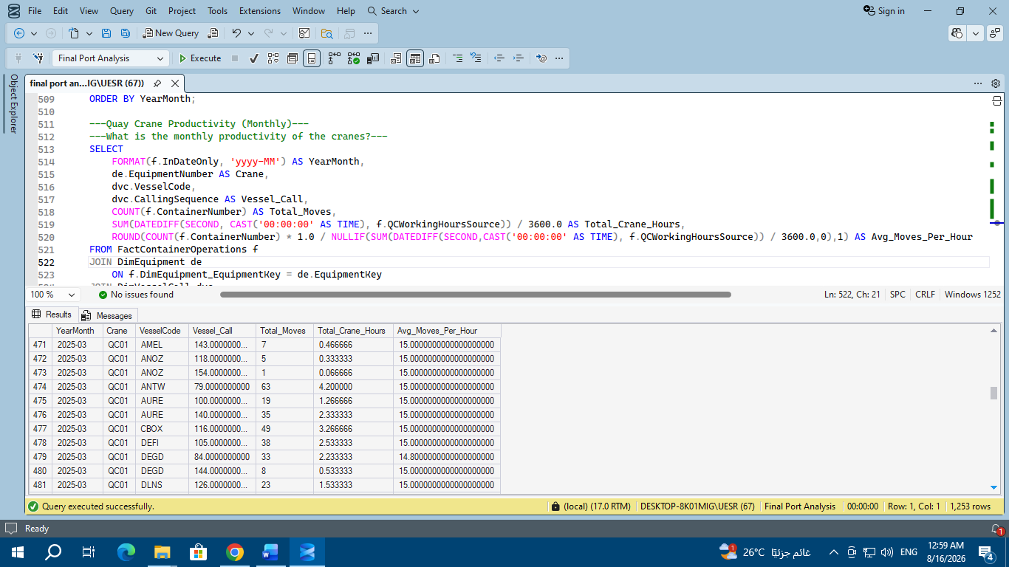
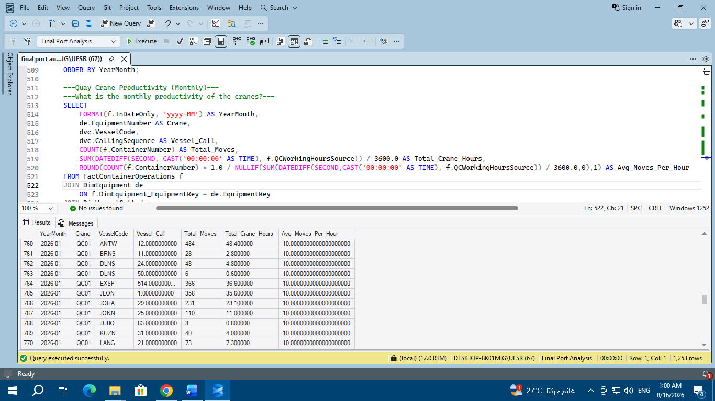
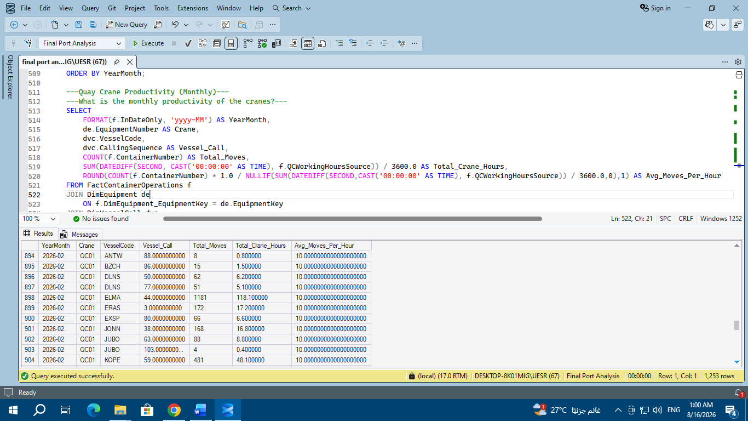
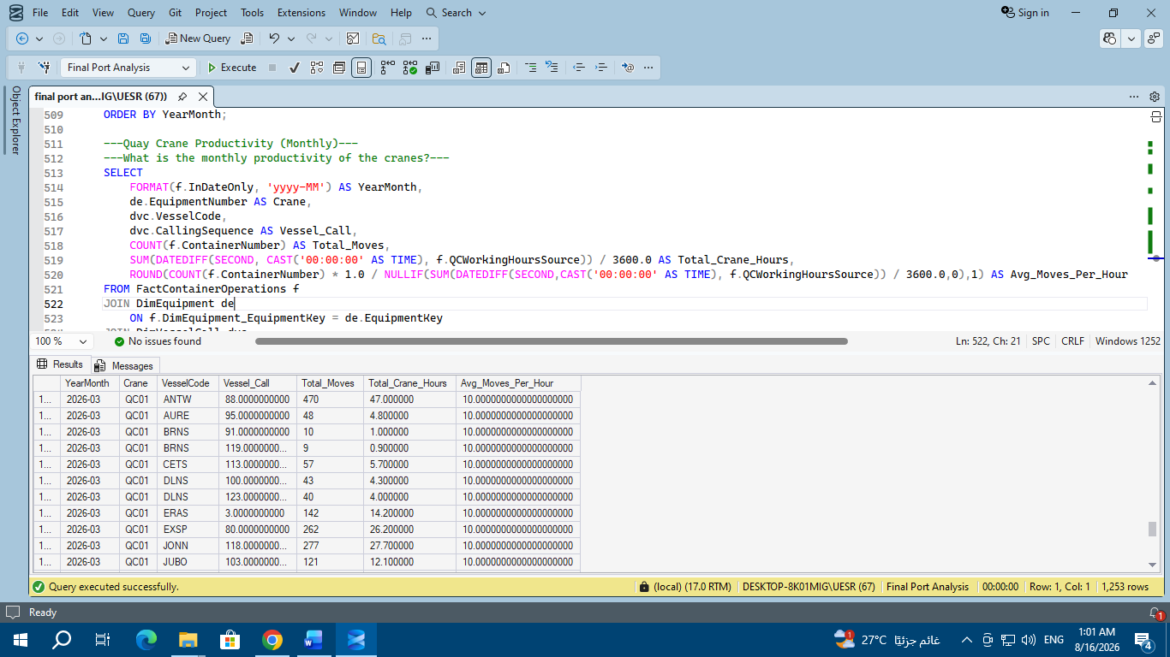
In 2025 (January, February, March): The Avg_Moves_Per_Hour column shows near-perfect stability at 15.0 moves/hour across the majority of vessels and cranes.

In 2026 (January, February, March): The rate drops to almost identical stability at 10.0 moves/hour across the various vessels and cranes.
- Monthly Quay Crane Productivity
SELECT
FORMAT(f.InDateOnly, 'yyyy-MM') AS YearMonth,
COUNT(f.ContainerNumber) AS Total_Moves,
SUM(DATEDIFF(SECOND, CAST('00:00:00' AS TIME), f.QCWorkingHoursSource)) / 3600.0 AS Total_Crane_Hours,
ROUND(COUNT(f.ContainerNumber) * 1.0 / NULLIF(SUM(DATEDIFF(SECOND, CAST('00:00:00' AS TIME), f.QCWorkingHoursSource)) / 3600.0,0),1) AS Moves_Per_Hour
FROM FactContainerOperations f
JOIN DimEquipment de
ON f.[DimEquipment_EquipmentKey] = de.EquipmentKey
WHERE de.EquipmentNumber IS NOT NULL
AND de.EquipmentNumber <> ''
AND MONTH(f.InDateOnly) IN (1, 2, 3)
GROUP BY FORMAT(f.InDateOnly, 'yyyy-MM')
ORDER BY YearMonth;
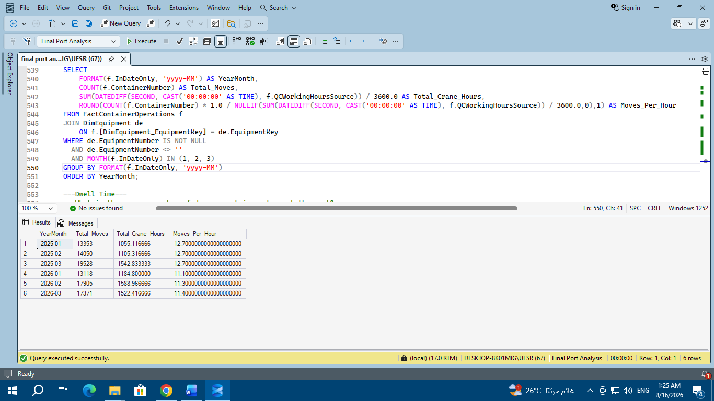

Crane productivity projected to decline in 2026 compared to 2025:

Q1 2025: Total crane productivity remained consistently at 12.7 moves/hours across all activity types during the three fastest months (January, February, and March).

Q1 2026: Total monthly productivity declined to an average of 11.1 to 11.4 moves/hours (January: 11.1, February: 11.3, March: 11.4), representing a decrease of approximately 11.8%.

Increased crane operating hours relative to the volume of moves:

In March 2025, 19,528 moves were performed using 1,542.8 crane operating hours.

In February 2026, 17,905 moves were performed using 1,588.9 crane operating hours. This means more operating hours were required to move fewer containers, which explains the decrease in the Moves Per Hour (MPH) efficiency.

Potential operational impacts:

This decrease may be due to slower unloading operations at the quay, routine crane maintenance, or operational congestion in the container yard that prevents the cranes from operating at their maximum productivity.

- What is the average number of days a container stays at the port? “Dwell Time”
SELECT
DATEPART(YEAR, f.InDateOnly) AS Year,
DATEPART(MONTH, f.InDateOnly) AS Month,
dtp.Mode,
AVG(f.StackDays) AS Avg_Stack_Days
FROM FactContainerOperations f
JOIN DimTransportProfile dtp ON f.[DimTransportProfile_TransportProfileKey] dtp.TransportProfileKey
WHERE f.OutDateOnly IS NOT NULL
AND MONTH(f.InDateOnly) IN (1, 2, 3)
GROUP BY dtp.Mode, DATEPART(YEAR, f.InDateOnly), DATEPART(MONTH, f.InDateOnly)
ORDER BY Year, Month;
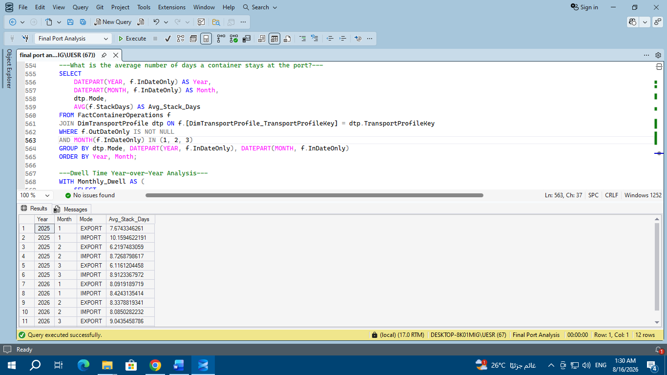
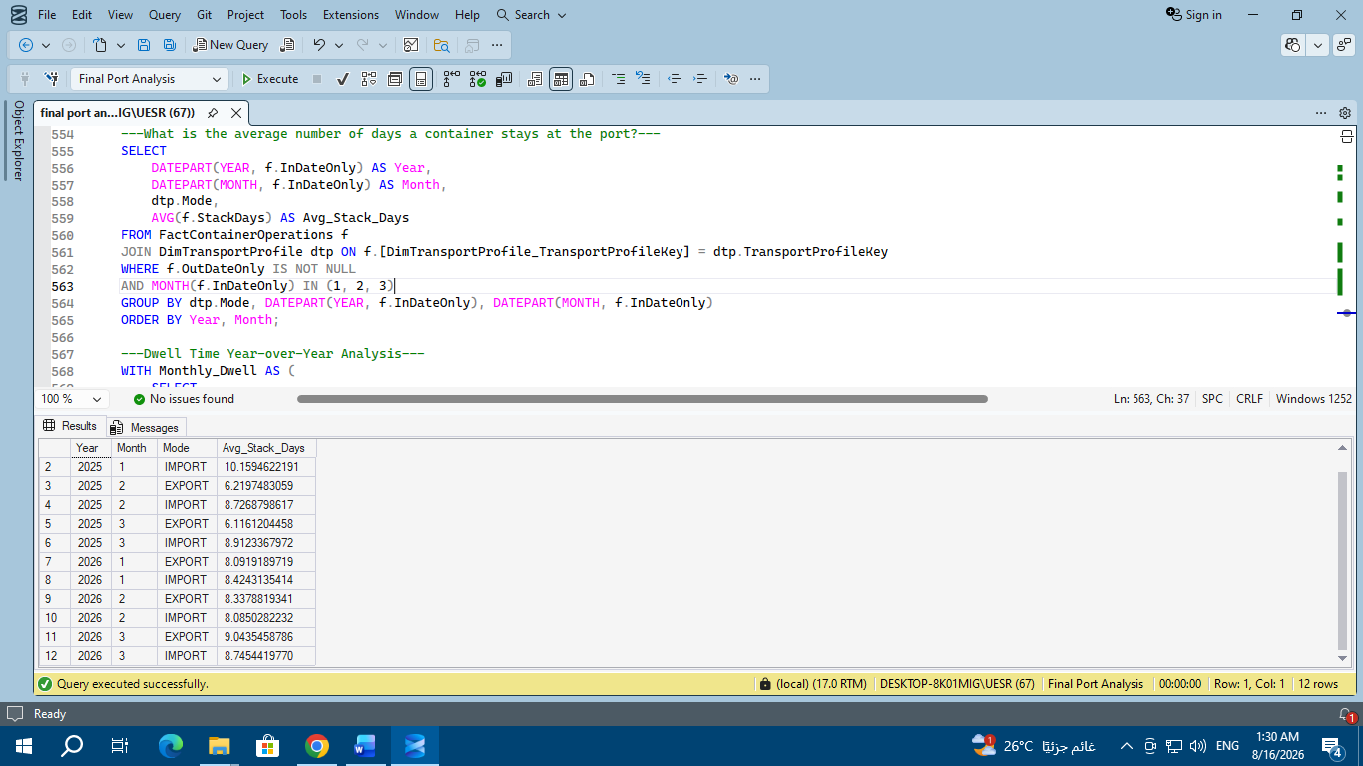

- Dwell Time Year-over-Year Analysis
WITH Monthly_Dwell AS (
SELECT
YEAR(f.InDateOnly) AS Year,
MONTH(f.InDateOnly) AS Month,
dtp.Mode,
AVG(f.StackDays) AS Avg_Dwell
FROM FactContainerOperations f
JOIN DimTransportProfile dtp ON f.[DimTransportProfile_TransportProfileKey] = dtp.TransportProfileKey
WHERE f.OutDateOnly IS NOT NULL
AND YEAR(f.InDateOnly) IN (2025, 2026)
AND MONTH(f.InDateOnly) IN (1, 2, 3)
GROUP BY
YEAR(f.InDateOnly),
MONTH(f.InDateOnly),
dtp.Mode)
SELECT
Month,
Mode,
ROUND(MAX(CASE WHEN Year = 2025 THEN Avg_Dwell END), 2) AS Dwell_2025,
ROUND(MAX(CASE WHEN Year = 2026 THEN Avg_Dwell END), 2) AS Dwell_2026,
ROUND((MAX(CASE WHEN Year = 2026 THEN Avg_Dwell END)
-
MAX(CASE WHEN Year = 2025 THEN Avg_Dwell END))
/NULLIF(MAX(CASE WHEN Year = 2025 THEN Avg_Dwell END), 0)* 100, 2) AS Change_Percentage
FROM Monthly_Dwell
GROUP BY Month, Mode
ORDER BY Month, Mode;
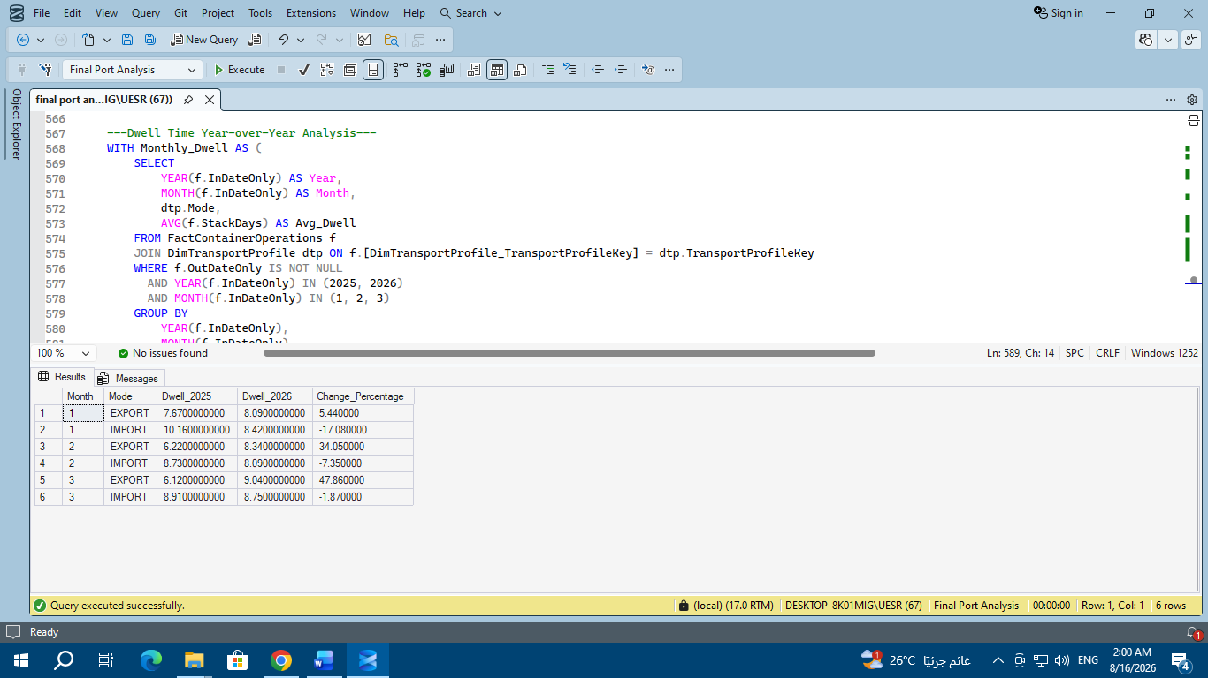

- How many containers/voyages/ships were exported and imported monthly, and what was the average Dwell Time per month?
SELECT
YEAR(f.InDateOnly) AS Year,
MONTH(f.InDateOnly) AS Month,
dtp.Mode,
COUNT(DISTINCT CONCAT(f.ContainerNumber, '-', dvc.UserVoyage)) AS Containers,
COUNT(DISTINCT dvc.UserVoyage) AS Voyages,
COUNT(DISTINCT CONCAT(dvc.VesselCode, '-', dvc.CallingSequence)) AS Vessel_Calls,
ROUND(AVG(f.StackDays), 2) AS Avg_Dwell_Time
FROM FactContainerOperations f
JOIN DimVesselCall dvc ON f.VesselCallKey = dvc.VesselCallKey
JOIN DimTransportProfile dtp ON f.[DimTransportProfile_TransportProfileKey] = dtp.TransportProfileKey
WHERE YEAR(f.InDateOnly) IN (2025, 2026)
AND MONTH(f.InDateOnly) IN (1, 2, 3)
GROUP BY
YEAR(f.InDateOnly),
MONTH(f.InDateOnly),
dtp.Mode
ORDER BY Year, Month, dtp.Mode;
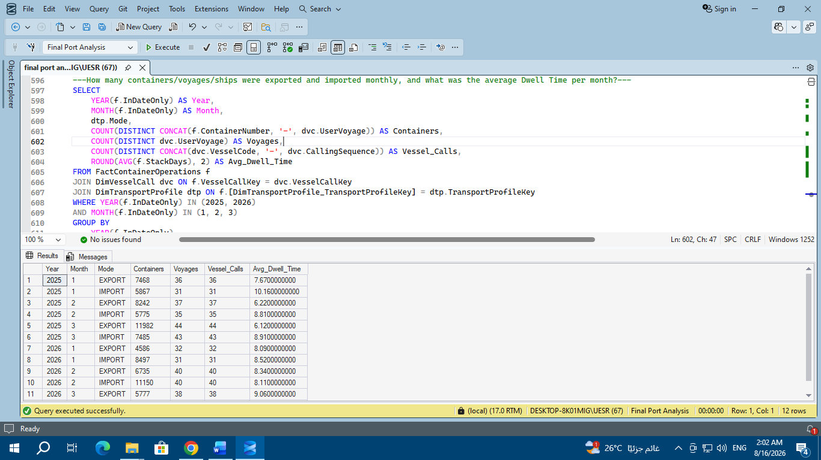
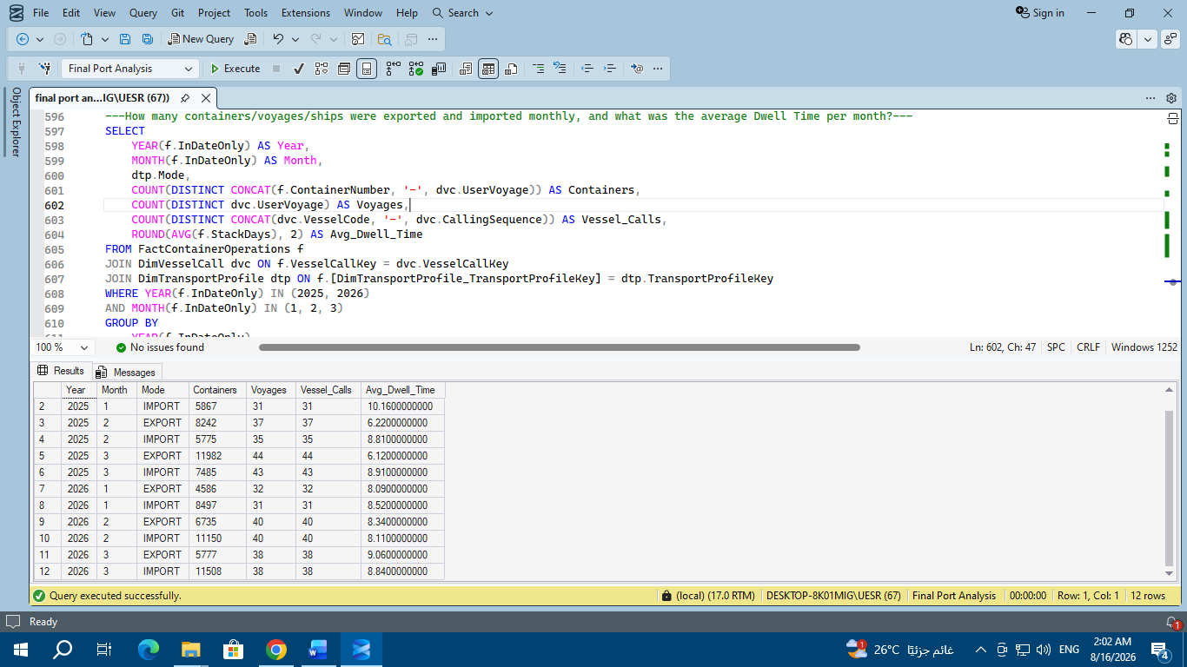
Decrease in Import Dwell Time:

In 2025: Import containers were spending relatively long periods in the port yards, recording 10.15 days in January, 8.72 days in February, and 8.91 days in March.

In 2026: Improvements in customs clearance and import logistics resulted in a decrease in dwell time to 8.42 days in January, 8.08 days in February, and 8.74 days in March.

Conclusion: The port became faster in processing and releasing import containers during 2026 compared to 2025.

Increased Export Container Dwell Time:

In 2025: Export containers spent less time in port before shipment, recording 7.67 days in January, then decreasing to 6.21 days in February and 6.11 days in March.

In 2026: Export container waiting time increased significantly, reaching 8.09 days in January, 8.33 days in February, and rising to 9.04 days in March.

Conclusion: There will be delays in shipping schedules or longer waiting times for containers to be connected to scheduled vessels in 2026.

The increased number of days exports remained at the port during February and March 2026 reflects the impact of supply chain disruptions and tensions. Export containers were deposited at the port, but ships were delayed or canceled their voyages, causing the containers to wait longer at the dock until they could be loaded.

- What is the average time for ship maneuvering? “Vessel Turnaround Time”
SELECT
DATEPART(YEAR, ATB) AS Year,
DATEPART(MONTH, ATB) AS Month,
AVG(VesselTurnaroundHours) AS Avg_Turnaround_Hours,
COUNT(*) AS Vessel_Calls
FROM FactVesselPortCalls
GROUP BY DATEPART(YEAR, ATB), DATEPART(MONTH, ATB)
ORDER BY Year, Month;
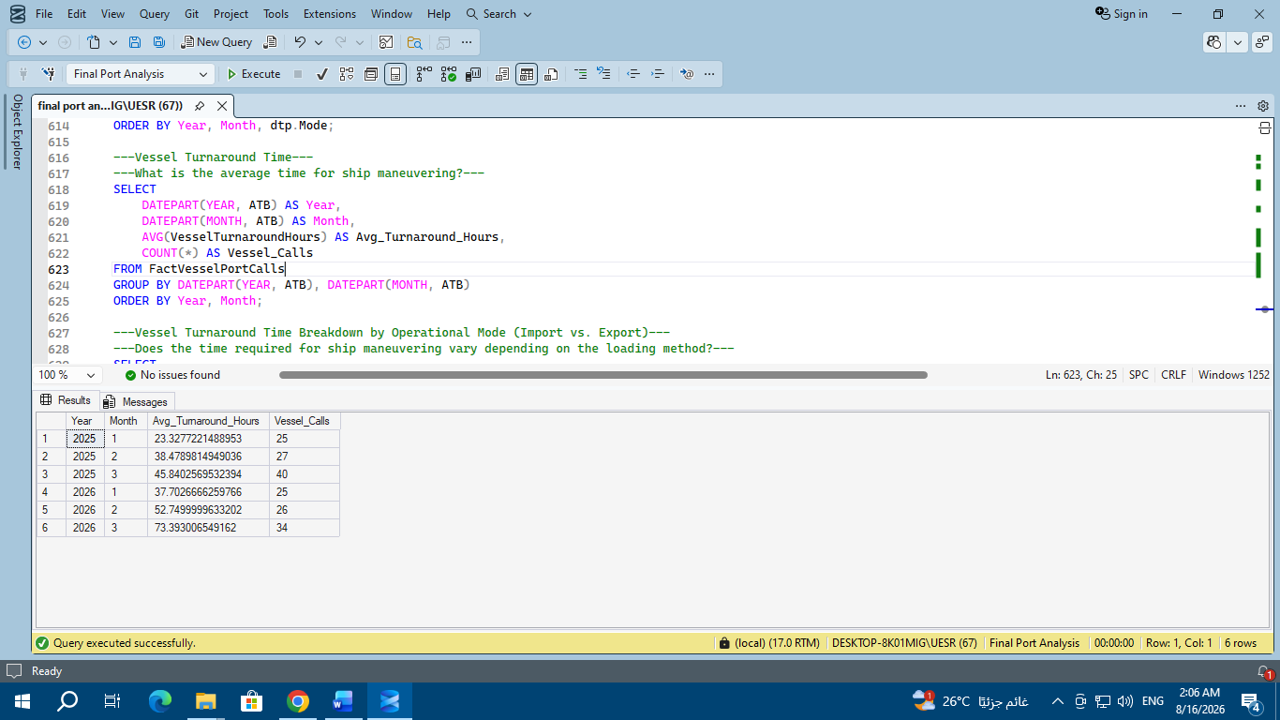

- Vessel Turnaround Time Breakdown by Operational Mode (Import vs. Export)
“Does the time required for ship maneuvering vary depending on the loading method?”

SELECT
DATEPART(YEAR, fvpc.ATB) AS Year,
DATEPART(MONTH, fvpc.ATB) AS Month,
dtp.Mode,
COUNT(DISTINCT fvpc.[Vessel_Code]) AS Vessels_Count,
ROUND(AVG(fvpc.VesselTurnaroundHours), 2) AS Avg_Turnaround_Hours
FROM FactVesselPortCalls fvpc
JOIN DimVesselCall dvc
ON CAST(fvpc.[Vessel_Code] AS NVARCHAR(50)) = CAST(dvc.VesselCode AS NVARCHAR(50))
AND CAST(fvpc.[User_Voy] AS NVARCHAR(50)) = CAST(dvc.UserVoyage AS NVARCHAR(50))
JOIN FactContainerOperations f
ON f.VesselCallKey = dvc.VesselCallKey
JOIN DimTransportProfile dtp
ON f.[DimTransportProfile_TransportProfileKey] = dtp.TransportProfileKey
WHERE DATEPART(MONTH, fvpc.ATB) IN (1, 2, 3)
AND DATEPART(YEAR, fvpc.ATB) IN (2025, 2026)
GROUP BY
DATEPART(YEAR, fvpc.ATB),
DATEPART(MONTH, fvpc.ATB),
dtp.Mode
ORDER BY Year, Month, dtp.Mode;
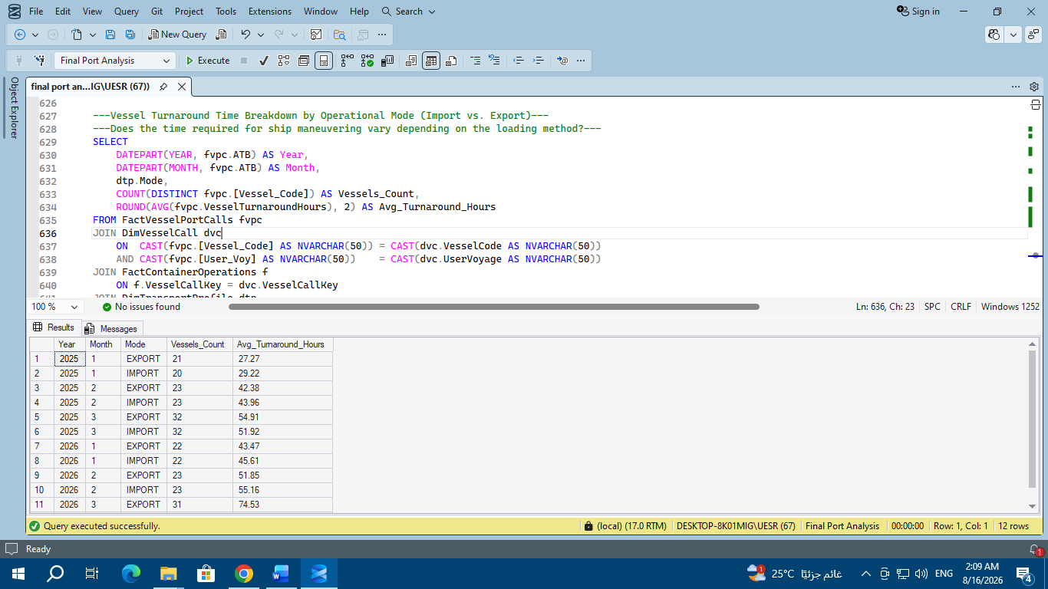
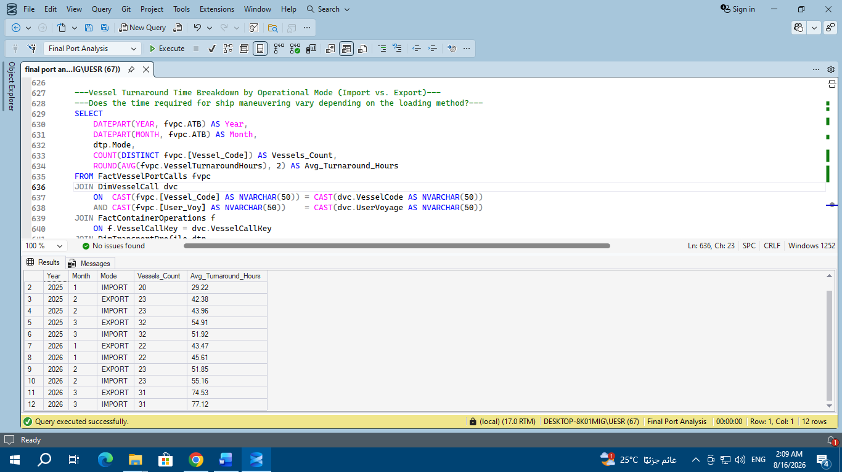

A sharp and gradual increase in vessel berth time (VTT Surge):

January: Average vessel berth time increased from approximately 28.2 hours in 2025 (27.27 outbound/29.22 inbound) to approximately 44.5 hours in 2026 (43.47 outbound/45.61 inbound).

February: Increased from approximately 43.1 hours in 2025 to approximately 53.5 hours in 2026.

March: Recorded the largest jump, increasing from approximately 53.4 hours in 2025 to over 75.8 hours in 2026 (74.53 outbound/77.12 inbound), an increase of over 41.9%.

Mode Symmetry Between Export and Import Turnaround Times:

The analysis reveals a very similar turnaround time for the same vessel, whether operating in export or import mode within the same month (a difference of only a few hours).

This confirms that the slowdown is due to overall port dynamics and berth operations, and not related to any specific loading or unloading method.

Root Cause Connection with Declining Crane Productivity:

This sharp increase in vessel berth time (reaching over 75 hours in March 2026) is directly related to the previous decline in crane productivity (from 15 to 10 moves/hour), forcing vessels to wait longer to complete loading and unloading the same number of containers.

- What is the import-to-export ratio for each year?
SELECT
dvc.CallingYear AS Year,
dtp.Mode,
COUNT(*) AS Total_Containers,
ROUND(COUNT(*) * 100.0 / SUM(COUNT(*)) OVER (PARTITION BY dvc.CallingYear), 1) AS Pct_Of_Year
FROM FactContainerOperations f
JOIN DimVesselCall dvc ON f.VesselCallKey = dvc.VesselCallKey
JOIN DimTransportProfile dtp ON f.[DimTransportProfile_TransportProfileKey] = dtp.TransportProfileKey
WHERE MONTH(f.InDateOnly) IN (1, 2, 3)
GROUP BY dvc.CallingYear, dtp.Mode
ORDER BY Year, dtp.Mode;
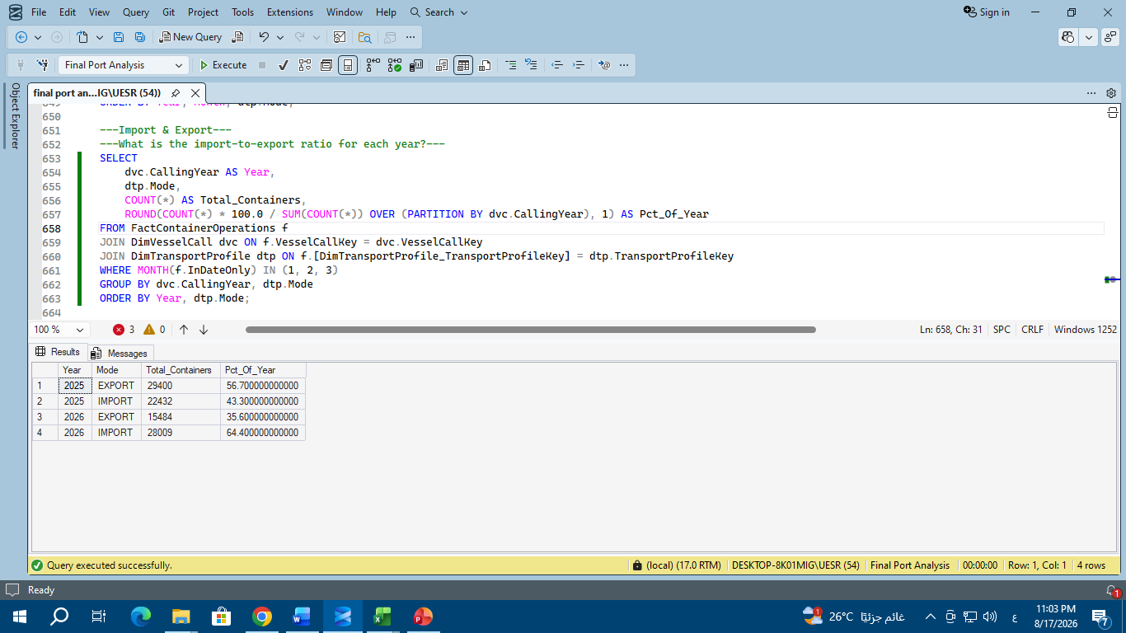
A radical shift in the port's trade pattern (Trade Balance Flip):

In 2025, the port was predominantly export-driven, accounting for 56.9% (29,634 TEUs) compared to 43.1% imports (22,462 TEUs).

In 2026, the balance completely reversed, with the port becoming predominantly import-driven, accounting for 64.1% (28,077 TEUs) compared to only 35.9% exports (15,697 TEUs).

A significant decline in total export traffic:

Export containers decreased by approximately 47% between the two years (from 29,634 to 15,697 TEUs), reflecting the impact of geopolitical instability and shipping delays on exports through this hub.

Significant growth in import traffic:

Import containers increased by approximately 25% (from 22,462 to 28,077 containers), which explains the significant pressure on unloading and storage operations within the port yards during 2026.

- What is the percentage of containers per country (by port of discharge) out of the total for each year?
WITH country_totals AS (
SELECT
dvc.CallingYear AS Year,
dpod.[POD_Master_Country] AS Country,
COUNT(*) AS Total_Containers
FROM FactContainerOperations f
JOIN DimVesselCall dvc ON f.VesselCallKey = dvc.VesselCallKey
JOIN DimPortPOD dpod ON f.PODKey = dpod.PODKey
GROUP BY dvc.CallingYear, dpod.[POD_Master_Country])
SELECT
Year,
Country,
Total_Containers,
ROUND(Total_Containers * 100.0 / SUM(Total_Containers) OVER (PARTITION BY Year), 1) AS Pct_Of_Year
FROM country_totals
ORDER BY Year, Total_Containers DESC;

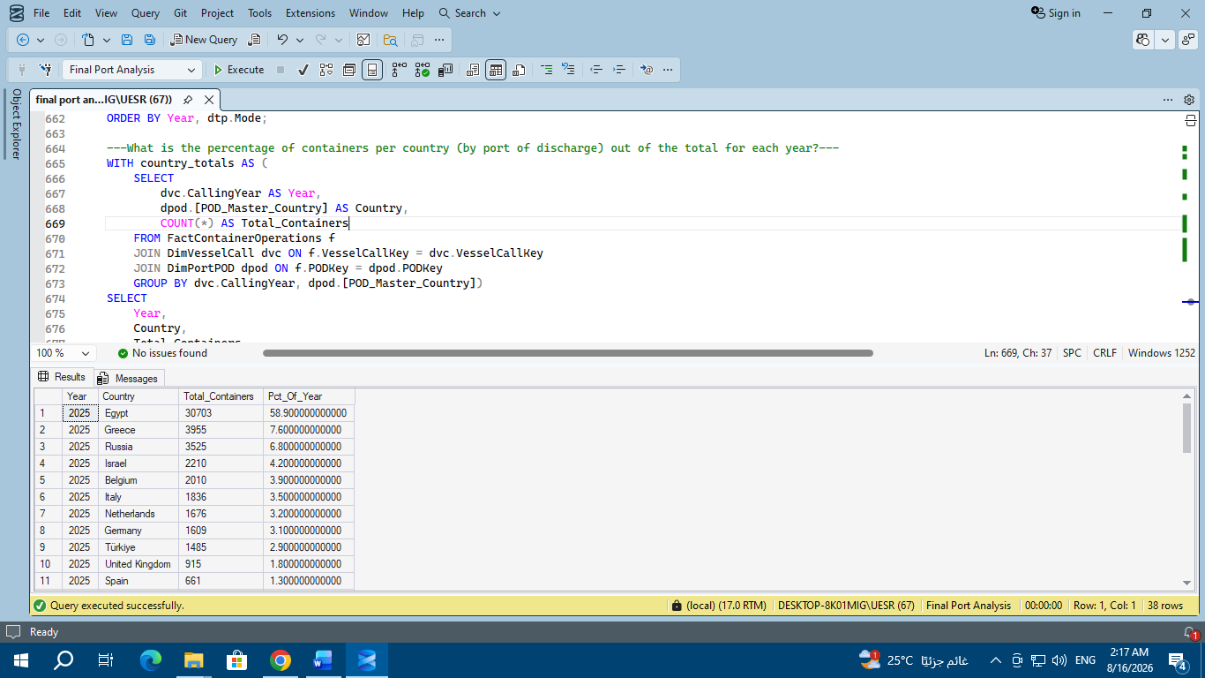

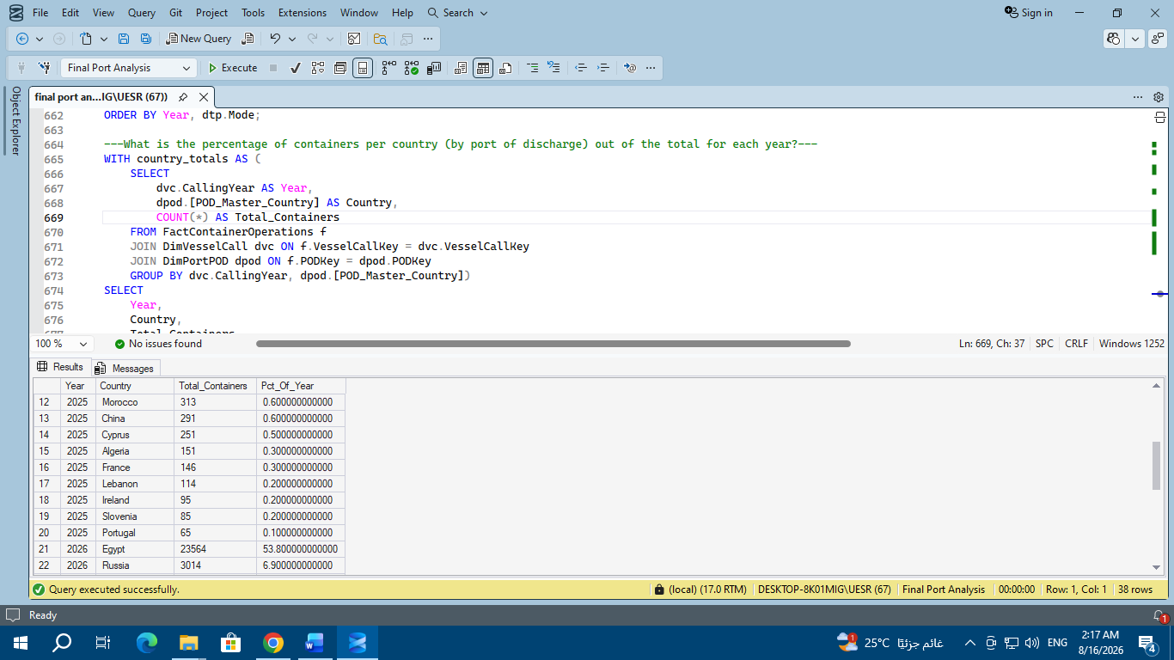
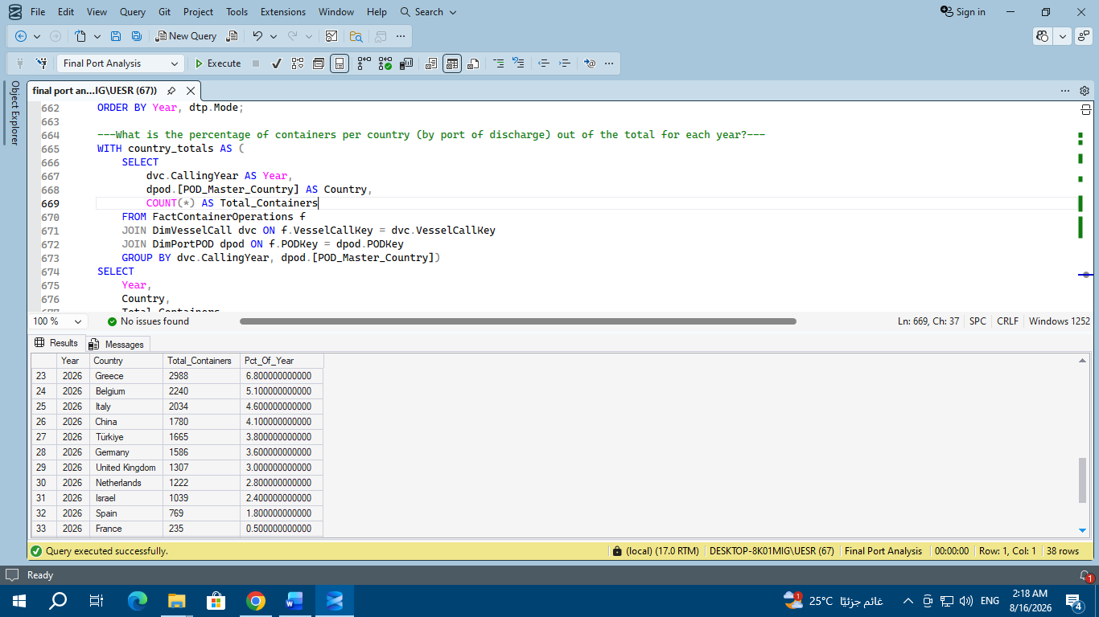
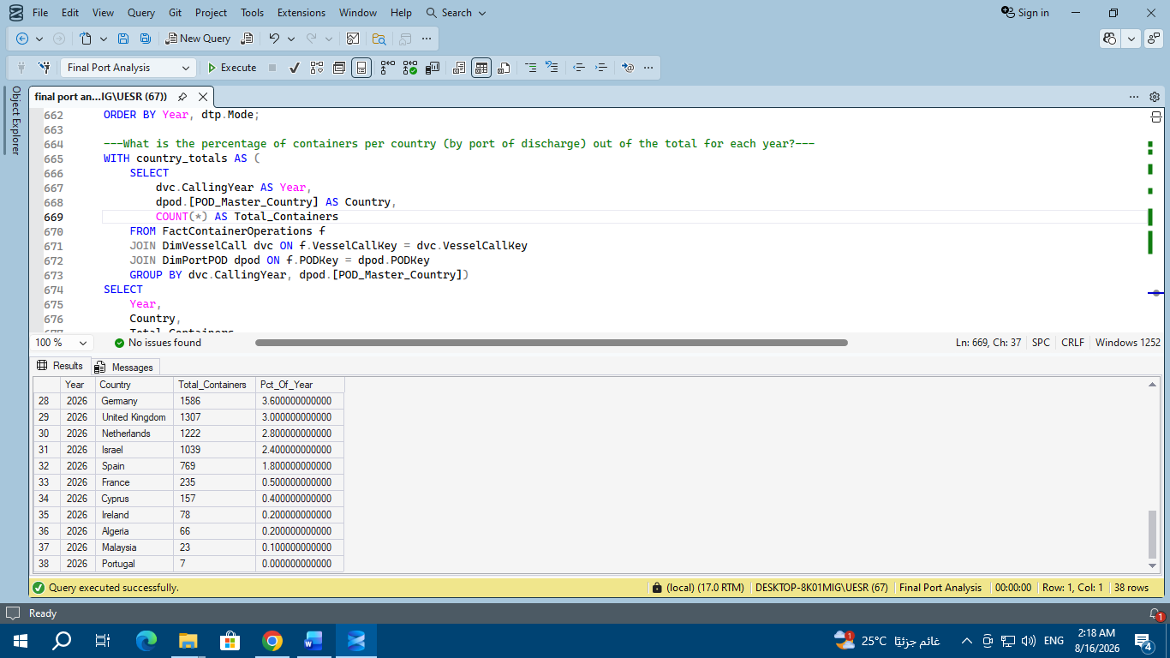

Egypt's Absolute Dominance as the Primary Destination:

2025: Egypt accounted for 58.9% of total container traffic (30,703 containers).

2026: Egypt maintained its leading position with 53.8% (23,564 containers), confirming that the terminal primarily functions as a domestic gateway port for Egyptian trade, not merely a transit port.

Stability of major trading partners in the Eastern Mediterranean and Europe:

Greece, Russia, Belgium, and Italy maintained their positions as the top five trading partners after Egypt in both years:

Russia: Its share increased from 6.8% (3,525 TEUs) in 2025 to 6.9% (3,014 TEUs) in 2026.

Greece: Its share was 7.6% in 2025 and 6.8% in 2026.

Belgium: Its share increased from 3.9% in 2025 to 5.1% in 2026.

Significant Growth in China's Share:

The number of containers destined for/unloaded for China jumped dramatically, from just 0.6% (291 containers) in 2025 to 4.1% (1,780 containers) in 2026, reflecting the expansion of direct shipping routes to Asian markets.

Declining Share of Some Regional Destinations (such as Israel):

The share of containers destined for Israel decreased from 4.2% (2,210 containers) in 2025 to 2.4% (1,039 containers) in 2026, influenced by geopolitical changes and shifts in regional shipping routes.

